WHAT WILL END THE LONG SLUMP?

Lessons from a Prototype Industry-Level

Production Account for the United States

by

Dale W. Jorgenson, Harvard University,

Mun S. Ho, Resources for the Future,

and

Jon D. Samuels, Bureau of Economic Analysis
December 31, 2013

Prepared for Presentation at the Session,

Has Innovation Stopped Driving Growth?

AEA/SPM

Philadelphia, Pennsylvania

January 4, 2013

WHAT WILL END THE LONG SLUMP?

Lessons from a Prototype Industry-Level Production

Account for the United States

by
Dale W. Jorgenson, Mun Ho, and Jon Samuels

Introduction

The Information Age is one of many terms that direct attention to the rapidly growing economic importance of information technology (IT). Economists were notoriously late in recognizing the widespread economic impact of IT, despite the currency that this trend achieved among journalists and futurologists. Jorgenson (2009) summarizes these developments and presents a collection of the key papers, beginning with the publication of Jorgenson and Kevin Stiroh (2000) and Steven Oliner and Dan Sichel (2000).
In Information Technology and the American Growth Resurgence. Jorgenson, Ho, and Stiroh (2005) analyzed the economic impact of IT at the aggregate level for 1948-2002 and the industry level for 1977-2000. They provided a concise history of the main technological innovations of the Information Age, beginning with the invention of the transistor in 1947. The year 1947 is also the initial year of the US National Income and Product Accounts (NIPAs) and the first benchmark input-output table. The year 2010 is the latest year for which the Annual Industry Economic Accounts are available. These are consistent with the NIPAs generated by the Bureau of Economic Analysis (BEA) and described by Nicole Mayerhauser and Erich Strassner (2010).
The purpose of this paper is to present a new data set on US productivity growth by industry for the period 1947-2010, exploiting data now available from the NIPAs, including the Industry Economic Accounts. This data set covers 65 industries and uses the North American Industry Classification System (NAICS). The US statistical system has shifted gradually to NAICS, beginning with the Business Census of 1997. The NIPAs converted to NAICS in the 2003 Comprehensive Revision.
The paper begins with a brief summary of the methodology for productivity measurement within the national accounts. The focus of productivity measurement has shifted from the economy as a whole to individual industries, especially those involved in the production and use of IT. Paul Schreyer’s OECD (2001) manual, Measuring Productivity has established international standards for economy-wide and industry-level productivity measurement. Our methodology is consistent with the OECD‘s international standards
The OECD standards are based on the industry-level production accounts constructed by Jorgenson, Frank Gollop, and Barbara Fraumeni (1987). These accounts were updated and revised to incorporate investments in IT hardware and software by Jorgenson, Ho, and Stiroh (2005). Jorgenson, Ho, and Samuels (2012) converted the industrial classification to NAICS and updated and extended the data to cover 70 industries for the period 1960-2007.
An important feature of our new data set is that we include output and intermediate input from the Industry Economic Accounts for the period 1998-2010, using BEA’s 65-sector industry classification. This will greatly ease the task of incorporating official industry data as they become available in the future. We have extrapolated the industry data backward from 1998, using information from our earlier studies as well as benchmark input-output tables beginning in 1947.
We aggregate industries by means of the production possibility frontier introduced by Jorgenson (1966) and employed by Jorgenson, Ho, and Stiroh (2005) and Jorgenson and Schreyer (2013). This provides a link between industry-level data and aggregate data, such as those of Harper, Moulton, Rosenthal, and Wasshausen (2009). Our data for individual industries could also be linked to firm-level data to incorporate differences in productivity levels among businesses that are the subject of the micro-economic research reviewed by Syverson (2011).
We illustrate the application of our prototype industry-level production account by analyzing data for the postwar US for three broad periods. These are the Postwar Recovery, 1947-1973, the Big Slump after the 1973 energy crisis, 1973-1995, and the period of Growth and Recession, 1995-2010. To provide more detail on the period of Growth and Recession, we consider the sub-periods 1995-2000, 2000-2005, and 2005-2010 – the Investment Boom, the Jobless Recovery, and the Great Recession. The final section of the paper summarizes our major conclusions.

Measuring Productivity in the National Accounts.

Jorgenson and Steven Landefeld (2006) have developed a new architecture for the NIPAs that includes prices and quantities of capital services for all productive assets in the US economy. The incorporation of the price and quantity of capital services into the United Nations’ System of National Accounts 2008 (SNA,2009) was approved by the United Nations (UN) Statistical Commission at its February-March 2007 meeting. The Statistical Commission reversed the position of the UN System of National Accounts 1993 (1993), which stated unequivocally that it was impossible to decompose income from capital (called net operating surplus) into price and quantity components.
Incorporation of data on labor and capital inputs in constant prices into the national accounts is described in Chapters 19 and 20 of the 2008 System of National Accounts, published in 2009. Jorgenson and Schreyer (2013) have shown how to integrate a complete system of production accounts at the industry level, like that provided by KLEMS data sets, into the 2008 System of National Accounts. To illustrate the application of these data sets they present a summary of the prototype production account for the United States for 1947-2010, described in more detail below.
Schreyer, then head of national accounts at the OECD, prepared an OECD Manual, Measuring Capital, published in 2009. This provides detailed recommendations on methods for the construction of prices and quantities of capital services. In Chapter 20 of SNA 2008 (page 415), estimates of capital services are described as follows: “By associating these estimates with the standard breakdown of value added, the contribution of labor and capital to production can be portrayed in a form ready for use in the analysis of productivity in a way entirely consistent with the accounts of the System.”
The measures of capital and labor inputs in the prototype system of US national accounts presented by Jorgenson and Landefeld (2006) are consistent with the OECD Productivity Manual, SNA 2008, and the OECD Manual, Measuring Capital. The volume measure of input is a quantity index of capital and labor services, while the volume measure of output is a quantity index of investment and consumption goods. Productivity is the ratio of output to input.
The hallmark of the framework for productivity measurement summarized by Jorgenson (2009) is the concept of capital services, including the services provided by IT equipment and software. The economics of IT begins with the staggering rates of decline in the prices of IT equipment used for storage of information and computing. The “killer application” of the new framework is the impact of IT investment.
Swiftly falling IT prices have provided powerful economic incentives for the rapid diffusion of IT through investment in hardware and software. A substantial acceleration in the IT price decline occurred in 1995, triggered by a much sharper acceleration in the price decline for semiconductors. The IT price decline after 1995 signaled even faster innovation in the main IT-producing industries – semiconductors, computers, communications equipment, and software -- and ignited a boom in IT investment. Our framework for productivity measurement provides the basis for distinguishing the economic impacts of innovation and investment.
Productivity growth is the key economic indicator of innovation. Economic growth can take place without innovation through replication of established technologies. Investment increases the availability of these technologies, while the labor force expands as population grows. With only replication and without innovation, output will increase in proportion to capital and labor inputs. By contrast the successful introduction of new products and new or altered processes, organization structures, systems, and business models generates growth of output that exceeds the growth of capital and labor inputs. This results in growth in productivity or output per unit of input.
We show that the great preponderance of economic growth in the US since 1947 involves the replication of existing technologies through investment in equipment and software and expansion of the labor force. Contrary to the well-known views of Robert Solow (1957) and Simon Kuznets (1971), innovation accounts for only about twenty percent of US economic growth. This is the most important empirical finding from the research on productivity measurement summarized by Jorgenson (2009).
The predominant role of replication of existing technologies in US economic growth is crucial to the formulation of economic policy. During the continuing recovery from the Great Recession of 2007-2009 in the US, economic policy must focus on maintaining the growth of employment and reviving investment. Policies that concentrate on enhancing the rate of innovation will have a very modest impact over the intermediate run. However, the growth of the US economy in the longer run depends critically on the performance of a relatively small number of sectors where innovation takes place.

Measuring Productivity at the Industry Level.

Disaggregating the production account by industrial sector requires the fully integrated system of input-output accounts and accounts for gross product originating by industry. Moyer (2012) described the integration of BEA’s industry data with the NIPAs, beginning with the benchmark revision published in July 2013. For the first time the NIPAs and the 2007 benchmark input-output table have been prepared within the same framework. The annual input-output data are consistent with the NIPAs and will be revised periodically, forming a continuous time series like the NIPAs.
BEA’s annual input-output data are employed in the industry-level production accounts presented by Susan Fleck, Rosenthal, Matthew Russell, Strassner, and Lisa Usher (2013) in their paper, “A Prototype BEA/BLS Industry-Level Production Account for the United States.” This covers the period 1998-2010 for the 65 industrial sectors used in the NIPAs. The capital and labor inputs are provided by BLS, while output and intermediate inputs are generated by BEA. Labor quality estimates are based on a slightly earlier version of our data set.
The EU (European Union)-KLEMS (capital, labor, energy, materials, and services) study, described by Marcel Timmer, Robert Inklaar, Mary O’Mahony and Bart van Ark (2010), was completed on June 30, 2008. This landmark study presents productivity measurements for 25 of the 27 EU members. The study also included data for Australia, Canada, Japan, and Korea, and the US, based on the methodology of Jorgenson, Ho, and Stiroh (2005).
Industry-level production accounts are now prepared on a regular basis by national statistical agencies in Australia, Canada, Denmark, Finland, Italy, Mexico, The Netherlands, and Sweden, as well as the United States. Augmented by production accounts from the EU-KLEMS project, these accounts can be used in international comparisons of patterns of structural change like those presented by Jorgenson and Timmer (2011). The World-KLEMS Initiative will make it possible to extend these comparisons to forty countries around the world, including important developing and transition economies.
Regional organizations in Asia and Latin America have joined the European Union in supporting research on KLEMS data sets. Due to the growing recognition of the importance of KLEMS data, an effort is underway to extend the KLEMS framework to emerging and transition economies. These include Argentina, Brazil, Chile, China, India, Indonesia, Mexico, Russia, Turkey, and Taiwan. Brazil, Russia, India, and China have been widely recognized as future leaders in the growth of the world economy.
The Latin American Chapter of the World-KLEMS Initiative, LA KLEMS, was established in December 2009 at a conference at ECLAC, the Economic Commission for Latin America and the Caribbean, in Santiago, Chile. This Chapter is coordinated by ECLAC and includes seven research organizations in four leading Latin American countries – Argentina, Brazil, Chile, and Mexico. Mario Cimoli, Andre Hofman, and Nanno Mulder (2010) summarize the results of the initial phase of the LA-KLEMS project.
The Asian Chapter of the World-KLEMS Initiative, Asia KLEMS, was founded in December 2010 and the first Asia-KLEMS Conference was held at the Asian Development Bank Institute in Tokyo in July 2011. The Asia-KLEMS Committee includes representatives of major Asian countries, including China, India, Japan, Korea, and Singapore. The second Asia- KLEMS Conference was held at the Bank of Korea in Seoul in August 2013.
International comparisons of patterns of output, inputs, and productivity are very challenging, but have become crucial to growth strategies in an increasingly globalized world economy. Research on international supply chains has established the need for integration of KLEMS data sets with information on trade. The World Input-Output Database (WIOD) augments industry-level data sets for the forty countries of the World-KLEMS Initiative with data on international trade among these countries. This project has produced a database that includes industry-level patterns of production and trade for all of the participating countries. The World Input-Output Database is a key resource for empirical research on international trade and the process of globalization.

A Prototype Industry-Level Production Account for the United States, 1947-2010.

In December 2011 the Bureau of Economic Analysis (BEA) released a new industry-level data set. This integrates three separate industry programs: benchmark input-output tables released every five years, annual input-output tables, and gross domestic product by industry, also released annually. The annual input-output tables and gross domestic product data by industry form consistent time series. The input-output tables provide data on the output side of the national accounts along with intermediate inputs in current and constant prices.
Mark Planting, formerly head of the input-output accounts at BEA, has developed a time
series of annual input-output tables in current prices covering the period 1947-1997 on a NAICS basis. This incorporates earlier benchmark input-output tables for the US, including the first benchmark table for 1947. BEA has linked these annual input-output tables to the official tables for 1998-2010.
We have constructed input-output tables in constant prices for 1947-2010, based on Jorgenson, Gollop, and Fraumeni for 1947-1979, Jorgenson, Ho, and Stiroh for 1977-2000, and Jorgenson, Ho, and Samuels (2012) for 1960-2007. We have revised, extended, and updated data on capital and labor inputs in constant prices from the same sources to obtain an industry-level production account for the United States, covering the period 1947-2010 in current and constant prices. This KLEMS data set is consistent with BEA’s annual input-output tables for 1998-2010.
The NAICS industry classification includes the industries identified by Jorgenson, Ho, and Samuels (2012) as IT-producing industries. These are computers and electronic products and two IT-services industries, information and data processing and computer systems design. Jorgenson, Ho and Samuels (2012) have classified industries as IT-using if the intensity of IT capital input is greater than the median for all US industries that do not produce IT equipment, software and services.
Value added in the IT-producing industries is only about three percent of the US economy, about 62 percent in the IT-using industries, and the remainder in the Non-IT industries. The IT-using industries are mainly in trade and services; most manufacturing industries are in the Non-IT sector. The NAICS industry classification provides much more detail on services and trade, especially for industries that are intensive users of IT. We begin by discussing the results for the IT-producing sectors, now defined to include the two IT-service sectors.
The contribution of each industry to value added is the growth rate of value added for the industry, weighted by its share in value added for the economy as a whole. Prices of computers and electronic products have declined rapidly, relative to the GDP deflator, since the commercialization of the electronic computer in 1959. This trend accelerated with the switch from vacuum tubes to semiconductors around 1970. The two IT-services sectors have had declining prices, relative to the GDP deflator, since around 2000.
Figure 1 reveals a steady increase in the share of IT-producing industries in value added since 1947. This is paralleled by a decline in the contribution of the Non-IT industries, while the share of IT-using industries has remained relatively constant. Figure 2 decomposes the growth of value added for the period 1995-2010. The contributions of the IT-producing and IT-using industries peaked during the Investment Boom of 1995-2000 and have declined since then. However, the contribution of the Non-IT industries has also declined sharply and became negative during the Great Recession.
Figure 3 gives the contributions to value added for the 65 individual industries over the period 1947-2010. Real estate, wholesale and retail trade, and computer and electronic products are the leading contributors, followed by state and local governments, broadcasting and telecommunications, miscellaneous professional, scientific, and technical services, and Federal Reserve banks, credit intermediation, and related activities. The contributions of oil and gas extraction, other mining, transit and ground passenger transportation, primary metals, rail transportation, and federal general government are negative but small in magnitude.
In order to assess the relative importance of productivity growth at the industry level as a source of US economic growth, we utilize the production possibility frontier of Jorgenson (1966). This gives the relationship between aggregate productivity growth and productivity growth at the industry level. The growth rate of aggregate productivity includes a weighted average of industry productivity growth rates, using the ingenious weighting scheme originated by Domar (1961).
In the Domar weighting scheme the productivity growth rate of each industry is weighted by the ratio of the industry’s gross output to aggregate value added. A distinctive feature of Domar weights is that they sum to more than one, reflecting the fact that an increase in the rate of growth of the industry’s productivity has two effects. The first is a direct effect on the industry’s output and the second an indirect effect via the output delivered to other industries as intermediate inputs.
The rate of growth of aggregate productivity also depends on the reallocations of capital and labor inputs among industries. The rate of aggregate productivity growth exceeds the Domar-weighted sum of industry productivity growth rates when these reallocations are positive. This occurs when capital and labor inputs are paid different prices in different industries and industries with higher prices have more rapid growth rates of the inputs. Under this assumption aggregate capital and labor inputs grow more rapidly than the Domar-weighted averages of industry capital and labor input growth rates, so that the reallocations are positive. When industries with lower prices for inputs grow more rapidly, the reallocations are negative.
Figure 4 shows that the contributions of IT-producing, IT-using, and Non-IT industries to aggregate productivity growth are similar in magnitude for the period 1947-2010. The Non-IT industries greatly predominated in the growth of value added during the Postwar Recovery, 1947-1973, but this contribution became negative after 1973. The contribution of IT-producing industries was relatively small during this Postwar Recovery, but became the predominant source of growth during the Big Slump, 1973-1995, and increased considerably during the period of Growth and Recession of 1995-2010. The IT-using industries contributed substantially to US economic growth during the postwar recovery, but disappeared during the Big Slump, 1973-1995, before reviving after 1995.
The reallocation of capital input made a small but positive contribution to growth of the US economy for the period 1947-2010, while the contribution of reallocation of labor input was negligible. Both reallocations were positive during the Postwar Recovery. Reallocation of capital input contributed positively to US productivity growth during the Big Slump, while reallocation of labor contributed negatively during this period. Both were negative but very small in magnitude during the period of Growth and Recession.
Considering the period 1995-2010 in more detail in Figure 5, the IT-producing industries predominated as a source of productivity growth during the period as a whole. The contribution of these industries remained substantial during each of sub-periods – 1995-2000, 2000-2005, and 2005-2010 – despite the powerful contraction of economic activity during the Great Recession of 2007-2009. The contribution of the IT-using industries was slightly greater than that of the IT-producing industries during the first two sub-periods, but became negative and small in magnitude during the Great Recession.
The Non-IT industries contributed positively to productivity growth during the Investment Boom of 1995-2000, but these contributions were almost negligible during the Jobless Recovery and became substantially negative during the Great Recession. The contributions of reallocations of capital and labor inputs were very small and negative during the period as a whole and fluctuated from negative in 1995-2000 to positive in 2000-2005. Figure 6 gives the contributions of each of the 65 industries to productivity growth for the period as a whole. The computer and electronic products industry was the leading contributor to US economic growth during this period, but important contributions were also made by real estate, wholesale and retail trade, and farms
Negative contributions to aggregate productivity for the period 1947-2010 as a whole were made by 29 of the 65 industries. The 29 industries include non-market services, such as health, education, and general government, as well as resource industries, such as oil and gas extraction and mining, except for oil and gas, affected by resource depletion. Other negative contributions reflect the growth of barriers to resource mobility in product and factor markets due, in some cases, to increased regulation. For example, utilities and primary metals have been strongly affected by more stringent environmental regulation and this has resulted in negative contributions to productivity growth.

Sources of US Economic Growth

The prices of capital inputs are essential for assessing the contribution of investment in IT equipment and software to economic growth. This contribution is the share of IT equipment and software in the value of output, multiplied by the rate of growth of IT capital input. A substantial part of the growing contribution of capital input in the US can be traced to the change in composition of investment associated with the growing importance of IT equipment and software. The most distinctive features of IT assets are the rapid declines in prices of these assets, as well as relatively high rates of depreciation.
The price of an asset is transformed into the price of the corresponding capital input by the cost of capital, introduced by Jorgenson (1963). The cost of capital includes the nominal rate of return, the rate of depreciation, and the rate of capital loss due to rising prices. The distinctive characteristics of IT prices – rapidly declining prices and high rates of depreciation – imply that cost of capital for IT capital inputs are very large relative to the cost of capital for Non-IT capital input.
The contributions of college-educated and non-college-educated workers to US economic growth are given by the relative shares of these workers in the value of output, multiplied by the growth rates of their hours worked. Personnel with a college degree or higher level of education correspond closely with “knowledge workers” who deal with information. Of course, not every knowledge worker is college-educated and not every college graduate is a knowledge worker.
Productivity growth is the key economic indicator of innovation. Although Solow (1957) and Kuznets (1971) have attributed most of US economic growth to growth in productivity, Figure 7 shows that the productivity growth was far less important than the contributions of capital and labor inputs. For the period 1947-2010 productivity accounts for about twenty percent of US economic growth. The contribution of capital input accounts for the largest share of growth for the period as a whole, while the contribution of labor input accounts for the rest.
The great preponderance of US economic growth is due to replication of established technologies rather than innovation. Innovation is obviously far more challenging and subject to much greater risk. The diffusion of successful innovation requires mammoth financial commitments. These fund the investments that replace outdated products and processes and establish new organization structures, systems, and business models. Although innovation accounts for a relatively modest portion of economic growth, we re-emphasize that this portion is vital for maintaining gains in the US standard of living in the long run.
The contribution of capital input exceeded that of innovation, while the contribution of labor input was similar to that of innovation during the Postwar Recovery, 1947-1973. The standard explanation for the relative importance of innovation during this period is the backlog of new civilian technologies available at the end of the World War II. During the Big Slump of 1973-1995, growth of inputs remained about the same. The “slump” was due to the sharp slowdown in productivity growth.
The contribution of labor input increased in importance during the Big Slump, relative to the contribution of capital input. The contributions of college-educated workers and investment in information technology grew substantially, while the contributions of non-college workers and non-information technology declined considerably. After 1995 the rate of US growth continued to decline and the contribution of non-college workers almost disappeared. Productivity growth revived, but failed to attain the high growth rate of the Postwar Recovery. Investment in IT became the predominant source of the contribution of capital input.
Figure 8 reveals that all of the sources of economic growth contributed to the US growth resurgence after 1995, relative to the Big Slump. Jorgenson, Ho, and Stiroh (2005) have analyzed the sources of the US growth resurgence in greater detail. After the dot-com crash in 2000 the overall growth rate of the US economy dropped to well below the long-term average of 1947-2010. The contribution of investment also declined below the long-term average, but the shift from Non-IT to IT capital input continued. Jorgenson, Ho, and Stiroh (2008) have shown that the rapid pace of US economic growth after 1995 was not sustainable.
The contribution of labor input dropped precipitously during the period of Growth and Recession, accounting for most of the decline in the rate of US economic growth during the Jobless Recovery. The contribution to growth by college-educated workers continued at a reduced rate, but that of non-college workers was negative. The most remarkable feature of the Jobless Recovery was the continued growth in productivity, indicating a continuing surge of innovation.
Both IT and Non-IT investment continued to contribute positively to US economic growth during the Great Recession period after 2005. The contribution of college-educated workers remained positive and substantial, while the contribution of non-college workers became strongly negative. These trends represent increased rates of substitution of capital for labor and college-educated workers for non-college workers.
Combining the results presented in Figures 2, 5, and 8, we arrive at an interpretation of the sources of the substantial growth deceleration during the Great Recession. A substantial part of the explanation is in the collapse of aggregate productivity growth. However, this was distributed very differently than during the Big Slump, when the Non-IT industries accounted for almost all of the slowdown in aggregate productivity growth.
During the Great Recession period 2005-2010, aggregate productivity growth became modestly negative. Only a minor portion of the drop in the growth rate was due to the IT-producing industries. Sharp declines took place in the contributions of IT-using industries and Non-IT industries. On balance, the negative contribution of productivity to US economic growth reflected the rising gap between actual and potential output during the Great Recession, especially during the recession period 2007-2009.
Continuing with our interpretation of the sources of growth during the Great Recession, Figure 8 reveals a modest slowdown in investment in IT equipment and software and Non-IT capital. However, the contribution of college-educated workers actually increased, while the decline in the contribution of non-college workers accelerated. The important contributors to the sharp slowdown in US economic growth also included the decline in the contribution of productivity growth in the IT-using industries from large and positive to slightly negative and a total collapse in the contribution of productivity growth in the Non-IT industries.
Our overall conclusion is that the decline in the contribution of the Non-IT industries to aggregate growth continued a trend that had been evident throughout the Information Age of 1947-2010. The contribution of these industries became negative during the Great Recession, resulting in a sharp acceleration in Creative Destruction. This term was employed by Joseph Schumpeter (1942) to capture the offsetting trends in rising and declining industries, especially during deep recessions.
The interpretation of the Great Recession as Accelerated Creative Destruction is rounded out by the collapse of productivity growth in the Non-IT industries and the negative and declining contributions of growth in labor input from non-college workers after the dot-com crash of 2000. The contribution of the IT-producing industries to aggregate productivity growth diminished only modestly. The revival of US economic growth will require falling unemployment, especially of college-educated workers, and the recovery of investment, especially in IT equipment and software, but also in Non-IT capital.

Conclusion

The new framework for productivity measurement employed in constructing KLEMS data sets reveals that replication of established technologies through growth of capital and labor inputs explains by far the largest proportion of US economic growth. Recently, this has involved the growth of college-educated workers and investments in both IT and Non-IT capital. International productivity comparisons reveal similar patterns for the world economy, its major regions, and leading industrialized, developing, and emerging economies. Studies are now underway to extend these comparisons to individual industries for the forty countries included in the World-KLEMS Initiative.
The behavior of productivity during the Great Recession of 2005-2010 highlights the role of Creative Destruction. The contribution of the Non-IT industries became substantially negative, even as the IT-producing industries continued to grow rapidly. Creative Destruction is also evident in negative growth of productivity in the Non-IT industries, beginning in 1973. This trend accelerated sharply during the Great Recession and was reinforced by a sharp decline in labor input from non-college workers.
The new findings presented in this paper have important implications for US economic policy. Maintaining the gradual recovery from the Great Recession will require stimulation of investment in IT equipment and software and Non-IT capital as well. Enhancing opportunities for employment is also essential, but this is likely to be most successful for college-educated workers. These measures will contribute to closing the substantial gap between potential and actual output that still remains four years after the end of the recession.

References

Aghion, Philippe, and Peter W. Howitt. 1998. Endogenous Growth Theory. Cambridge, MA: The
MIT Press.
Fleck, Susan, Steven Rosenthal, Matthew Russell, Erich Strassner, and Lisa Usher. 2013. A
Prototype BEA/BLS Industry-Level Production Account for the United States. In Dale W. Jorgenson, J. Steven Landefeld, and Paul Schreyer, eds., Measuring Economic Stability and Progress. Chicago: University of Chicago Press: forthcoming.
Harper, Michael, Brent Moulton, Steven Rosenthal, and David Wasshausen. 2009. Integrated
GDP-Productivity Accounts. American Economic Review 99(2): 74-79.
Hofman, Andre. 2012. Overview of LA-KLEMS. Presentation to the Second World KLEMS
Conference, Harvard University, Cambridge, MA. See: http://www.economics.harvard.edu/faculty/jorgenson/WorldKLEMS
Jorgenson, Dale W. 1963. Capital Theory and Investment Behavior. American Economic Review
53(2): 247-259.
Jorgenson, Dale W. 1966. The Embodiment Hypothesis. Journal of Political Economy 74(1): 1-
17
Jorgenson, Dale W., ed., 2009. The Economics of Productivity. Northampton, MA: Edward Elgar.
Jorgenson, Dale W. 2012. The World KLEMS Initiative. International Productivity Monitor,
Fall: 5-19.
Jorgenson, Dale W., Frank M. Gollop, and Barbara M. Fraumeni. 1987. Productivity and U.S.
Economic Growth. Cambridge MA: Harvard University Press.
Jorgenson, Dale W., Mun S. Ho, and Jon Samuels. 2012. Information Technology and U.S.
Productivity Growth. In Matilde Mas and Robert Stehrer, eds., Industrial Productivity in Europe, Northampton, MA, Edward Elgar: 34-65.
Jorgenson, Dale W., Mun S. Ho, and Kevin J. Stiroh. 2005. Information Technology and the
American Growth Resurgence. Cambridge, MA: The MIT Press.
Jorgenson, Dale W., and J. Steven Landefeld. 2006. Blueprint for an Expanded and Integrated
U.S. National Accounts: Review, Assessment, and Next Steps. In Dale W. Jorgenson, J. Steven Landefeld, and William D. Nordhaus, eds., A New Architecture for the U.S. National Accounts. Chicago: University of Chicago Press: 13-112.
Jorgenson, Dale W., and Paul Schreyer. 2013. Industry-Level Productivity Measurement and the
2008 System of National Accounts. Review of Income and Wealth 58(4): 185-211.
Jorgenson, Dale W., and Marcel P. Timmer. 2011. Structural Change in Advanced Nations: A
New Set of Stylized Facts. Scandinavian Economic Journal 113(1): 1-29.
Jorgenson, Dale W., and Khuong M. Vu. 2013. The Emergence of the New Economic Order:
Economic Growth in the G7 and the G20. Journal of Policy Modeling, 35(2): 389-399.
Kuznets, Simon. 1971. Economic Growth of Nations: Total Output and Production Structure.
Cambridge, MA: Harvard University Press. .
Mas, Matilde, and Robert Stehrer, eds. 2012. Industrial Productivity in Europe. Northampton, MA,
Edward Elgar.
Mayerhauser, Nicole, and Erich Strassner. 2010. Preview of the Comprehensive Revision of the
Annual Industry Accounts. Survey of Current Business, 90(3): 21-34.
Moyer, Brian. 2012. Integration of the U.S. Industry Accounts and the NIPAs. Presentation to the
Second World KLEMS Conference, Harvard University, Cambridge, MA. See:http://www.economics.harvard.edu/faculty/jorgenson/WorldKLEMS
Pyo, Hak Kil. 2012. Overview of Asia KLEMS. Presentation to the Second World KLEMS
Conference, Harvard University, Cambridge, MA. See:
http://www.economics.harvard.edu/faculty/jorgenson/WorldKLEMS
Schreyer, Paul. 2001. OECD Manual: Measuring Productivity: Measurement of Aggregate and
Industry-Level Productivity Growth. Paris: Organisation for Economic Development and Cooperation.
Schreyer, Paul. 2009. OECD Manual: Measuring Capital. Paris: Organisation for Economic
Development and Cooperation.
Schreyer, Paul, 2012. From the OECD Productivity Handbook to World KLEMS. Presentation to
the Second World KLEMS Conference, Harvard University, Cambridge, MA. See:
http://www.economics.harvard.edu/faculty/jorgenson/WorldKLEMS
Schumpeter, Joseph A. 1942. Capitalism, Socialism, and Democracy. New York: Harper.
Solow, Robert M. 1957. Technical Change and the Aggregate Production Function. Review of
Economics and Statistics 39(3):312-320.
Syverson, Chad. 2011. What Determines Productivity? Journal of Economic Literature 49(2): 325-
365.
Timmer, Marcel. 2012. World KLEMS Initiative: The Future. Presentation to the
Second World KLEMS Conference, Harvard University, Cambridge, MA.
See: http://www.economics.harvard.edu/faculty/jorgenson/WorldKLEMS
Timmer, Marcel, Robert Inklaar, Mary O’Mahony, and Bart van Ark. 2010. Economic Growth in
Europe: A Comparative Industry Perspective, Cambridge, Cambridge University Press.
United Nations, Commission of the European Communities, International Monetary Fund,
Organisation for Economic Co-operation and Development, and World Bank. 2009. System of National Accounts 2008. New York, United Nations.
See: http://unstats.un.org/unsd/nationalaccount/sna2008.asp.
United Nations, Commission of the European Communities, International Monetary Fund,
Organisation for Economic Co-operation and Development, and World Bank. 1993. System of National Accounts 1993. New York, United Nations.

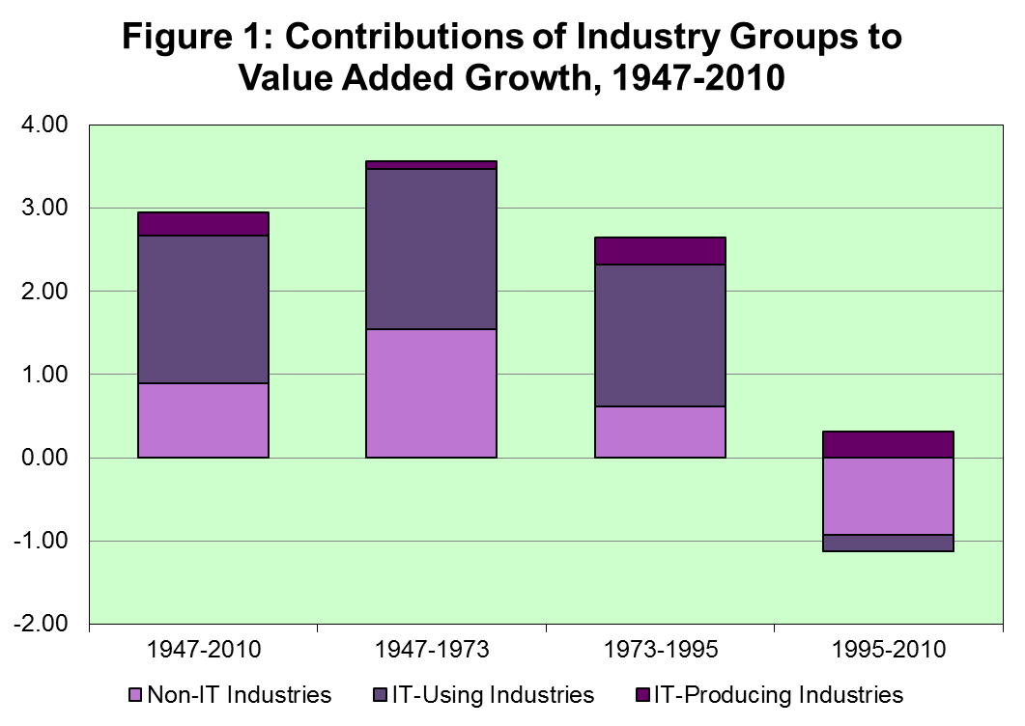

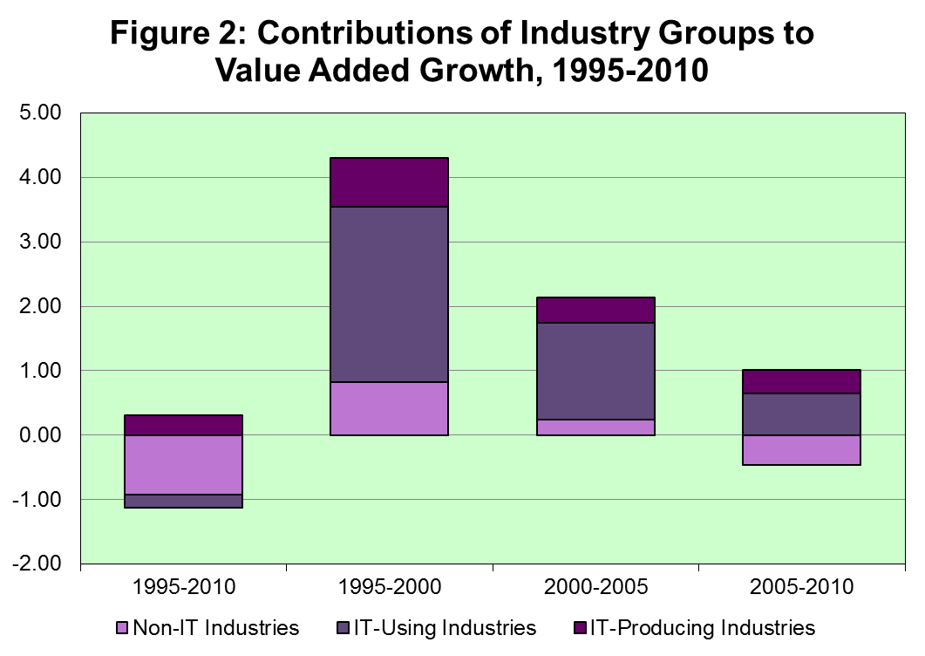

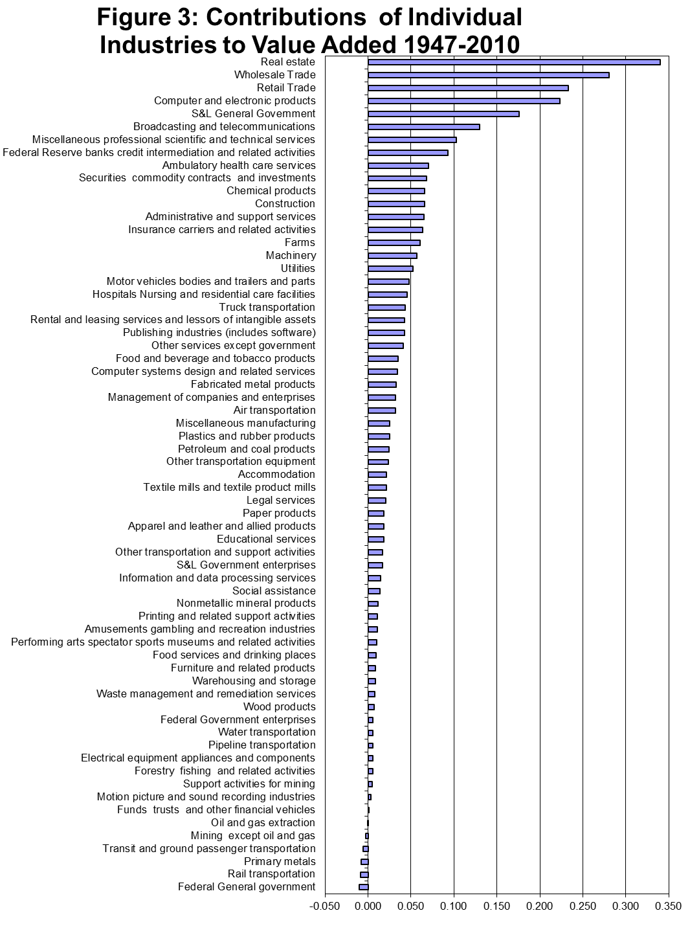

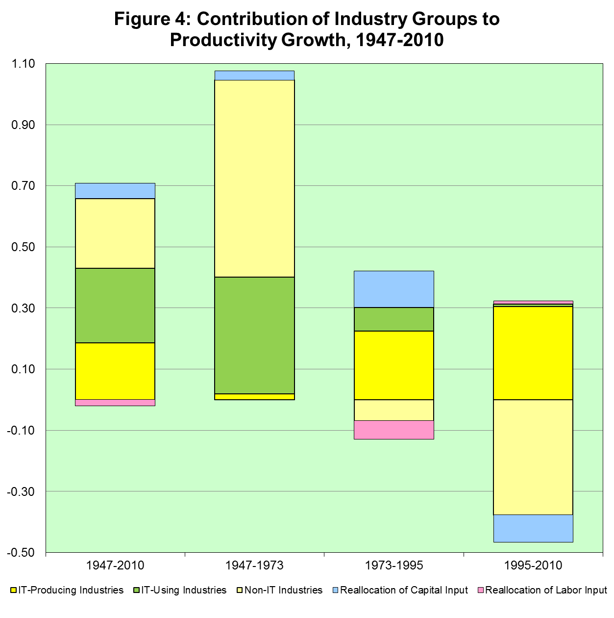

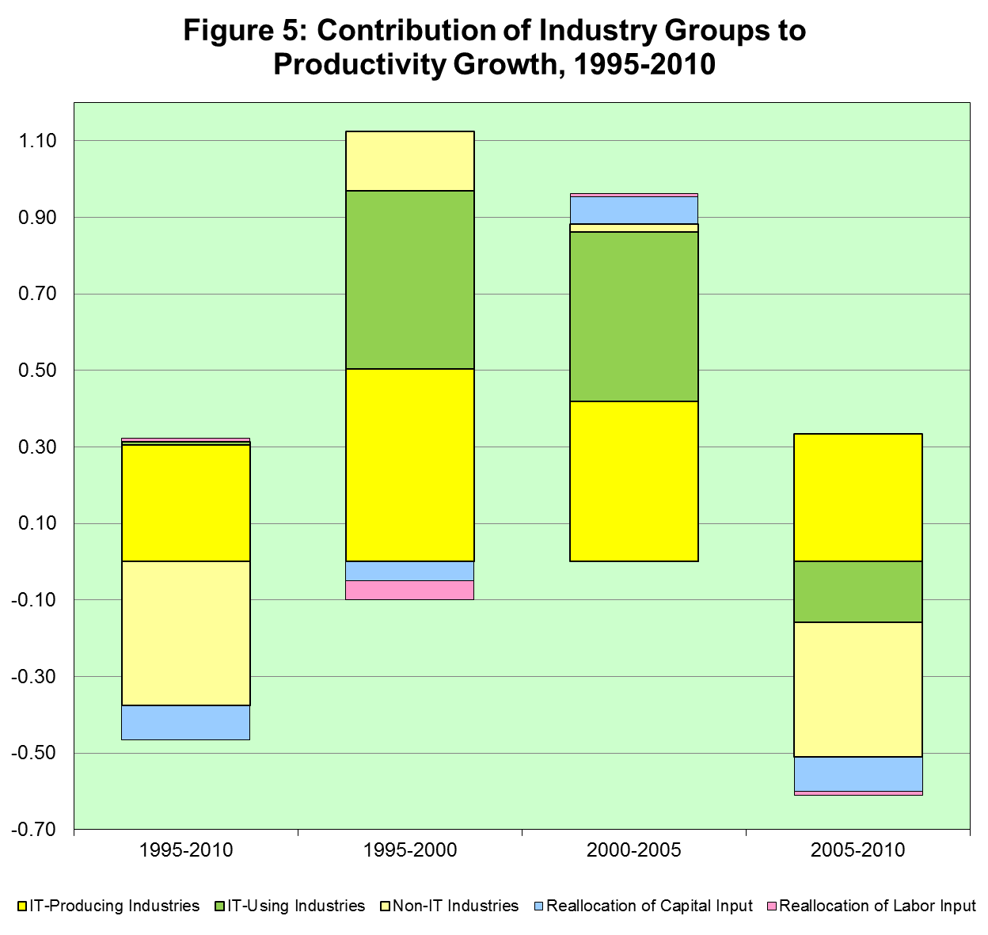

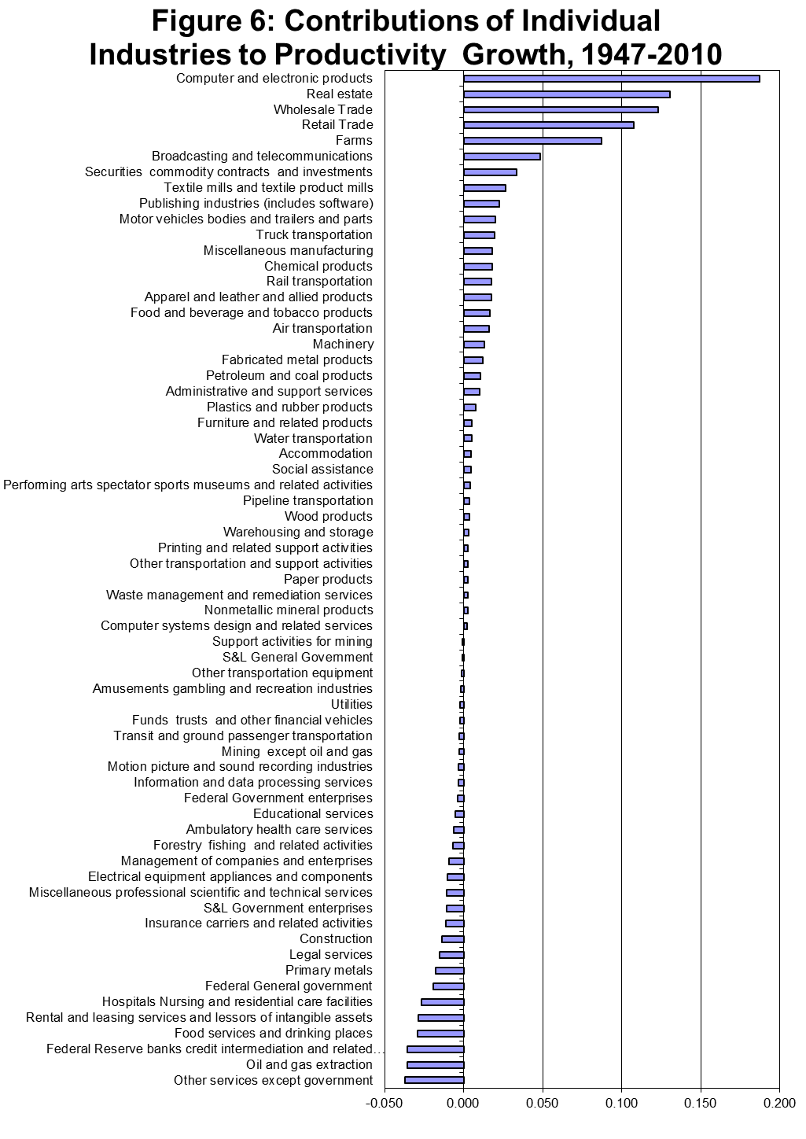
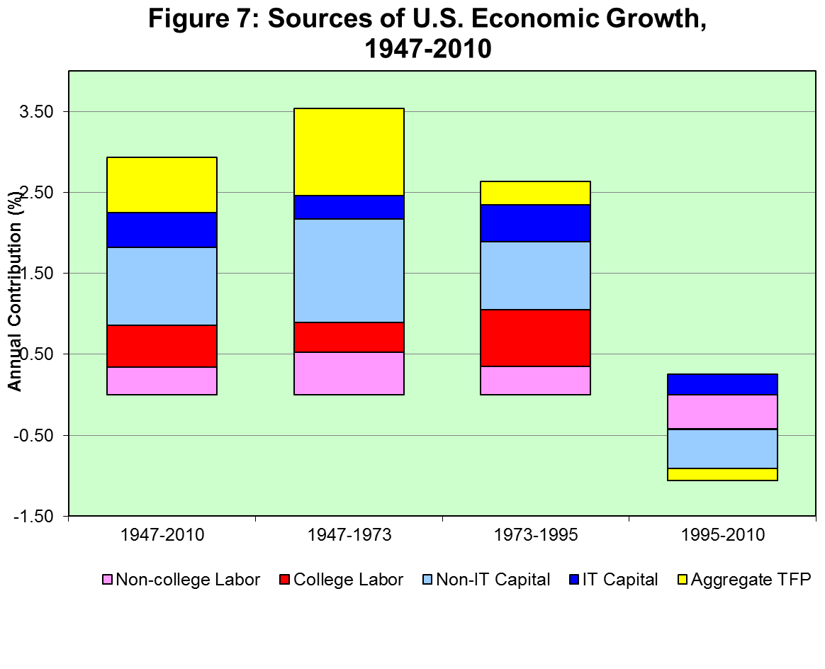
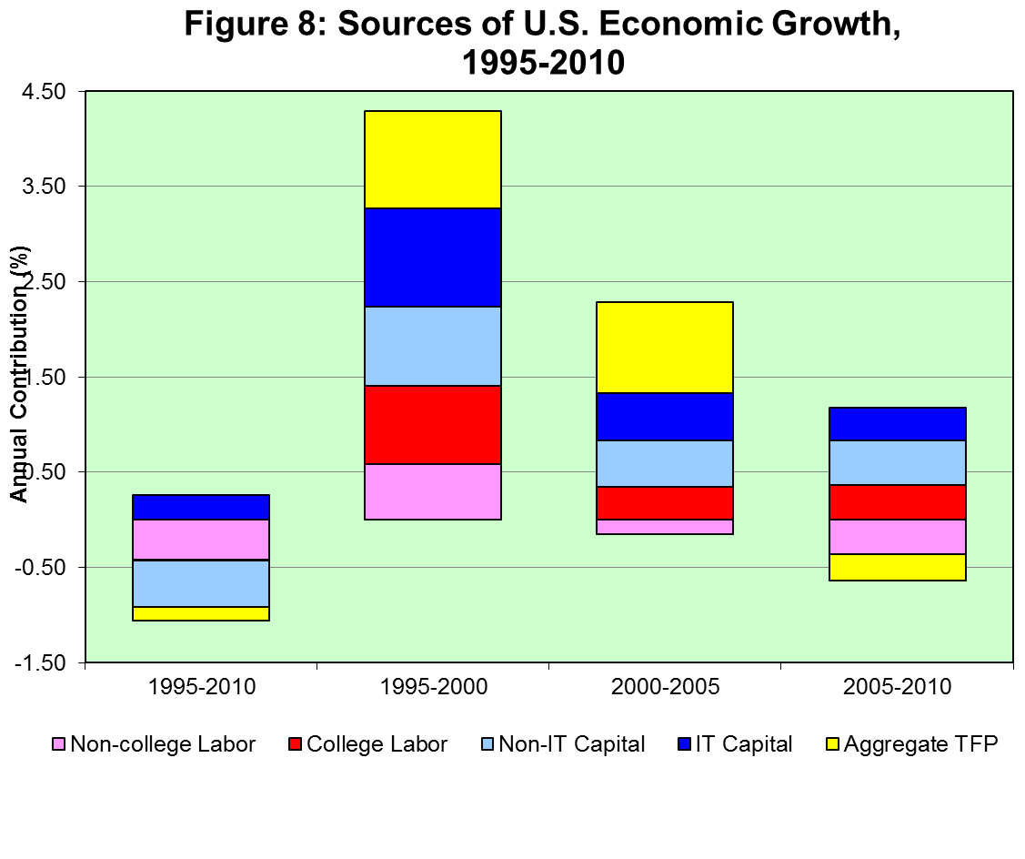

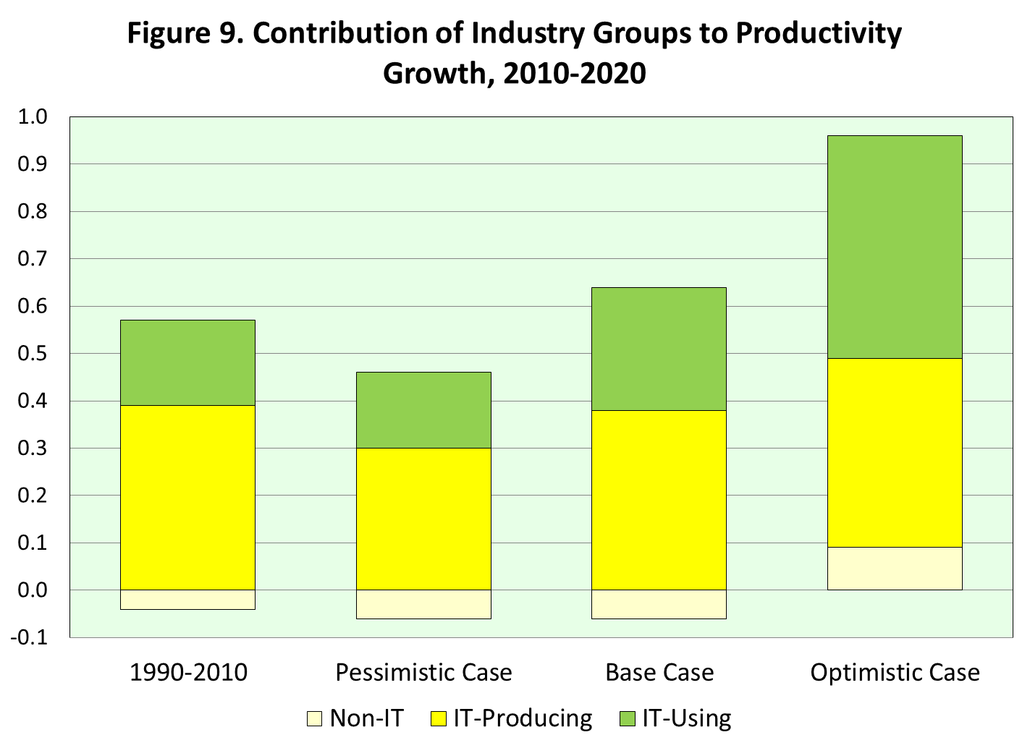

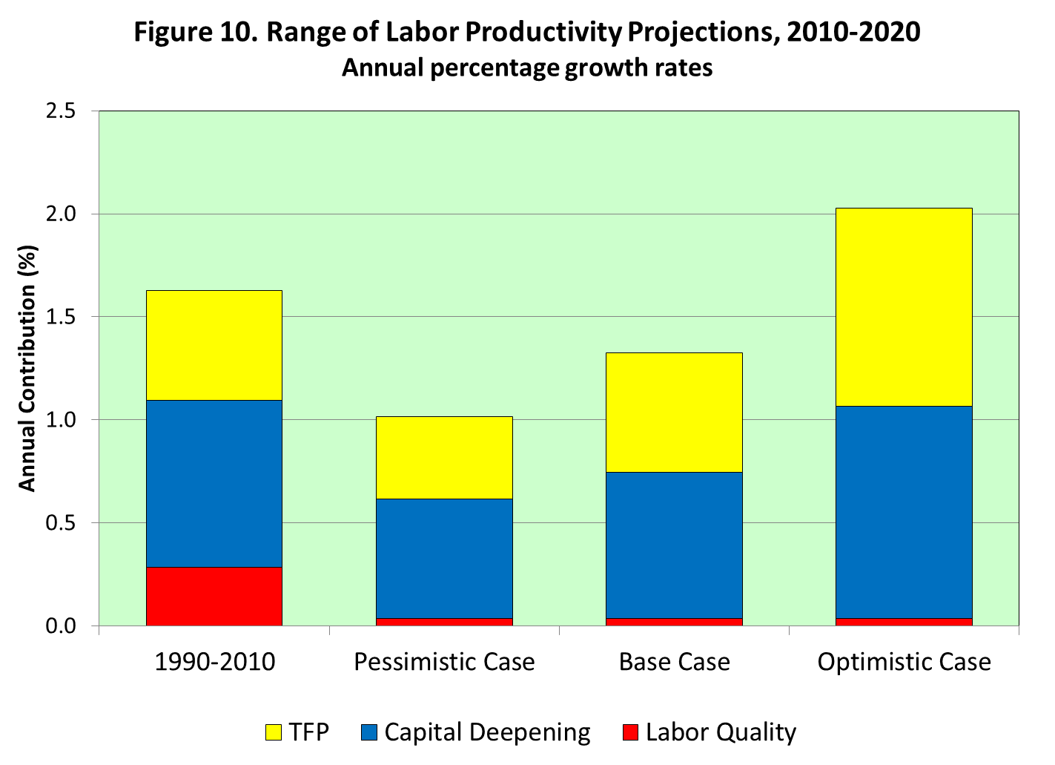

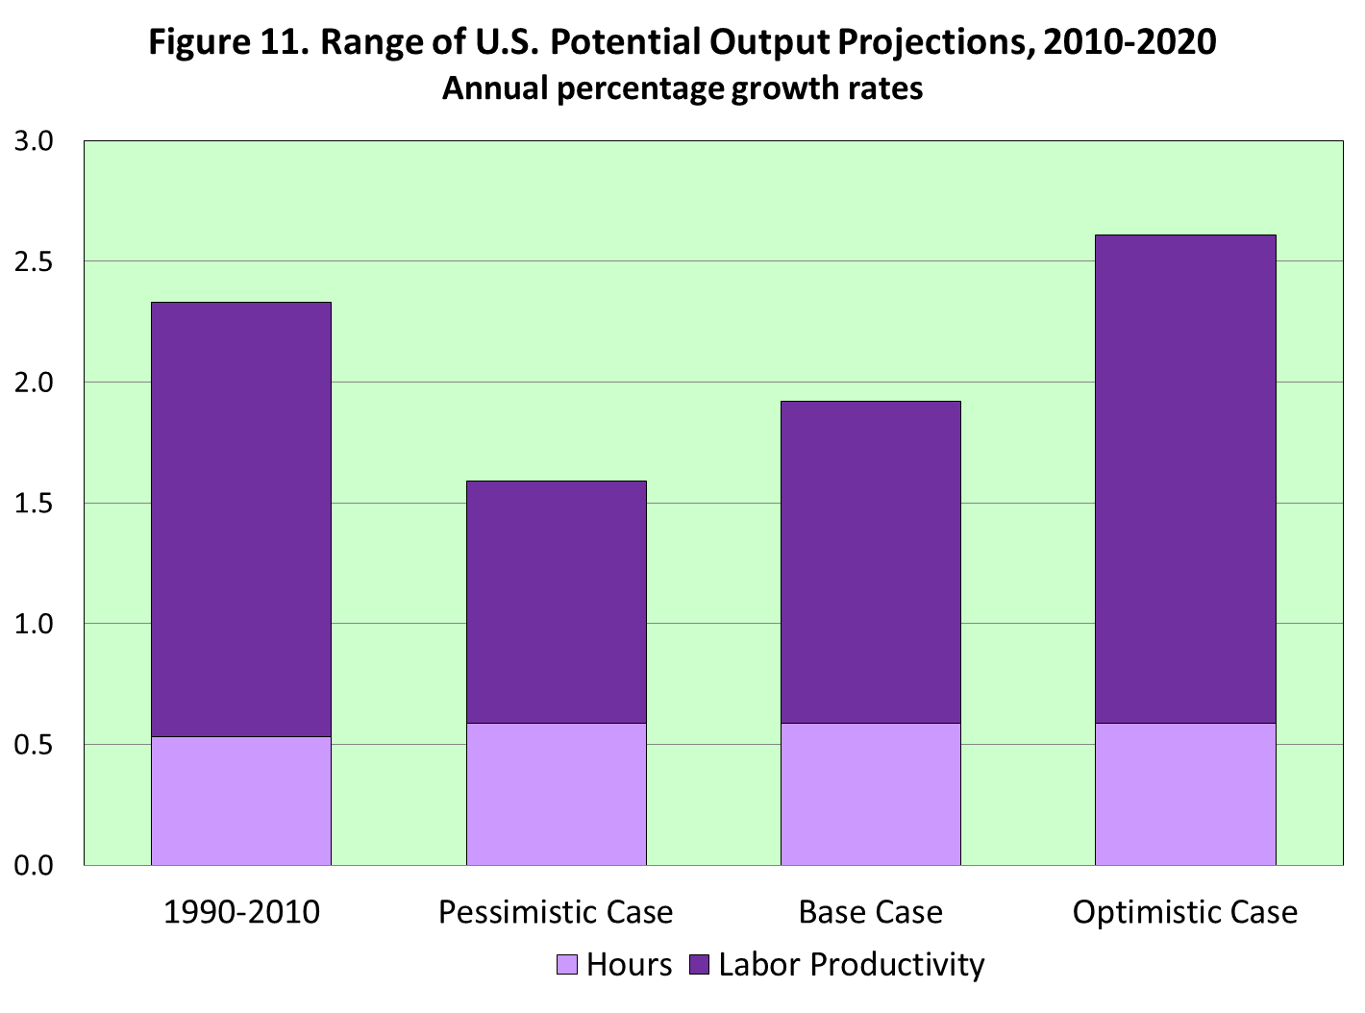

The views expressed in this paper are solely those of the authors and not necessarily those of the U.S. Bureau of Economic Analysis or the U.S. Department of Commerce.
See: http://scholar.harvard.edu/jorgenson/publications/economics-productivity
See: http://mitpress.mit.edu/books/productivity-0
United Nations, System of National Accounts 1993, p. 403.
/.
For current data, see: http://www.bea.gov/. BEA’s data on output and intermediated inputs for 1998-2010 are included in our prototype industry-level production account for 1947-2010.
Current data for the participating countries are available at the EU KLEMS website: http://www.euklems.net.
See Jorgenson (2012), “The World KLEMS Initiative,” International Productivity Monitor, Fall, pp. 5-19.
Additional information about LA KLEMS is available on the project website: http://www.cepal.org/cgi-bin/getprod.asp?xml=/la-klems/noticias/paginas/4/40294/P40294.xml&xsl=/la-klems/tpl-i/p18f-st.xsl&base=/la-klems/tpl-i/top-bottom.xsl An overview of LA-KLEMS is presented by Hofman (2012).
Additional information about Asia KLEMS is available on the project website: http://asiaklems.net/1_1.html An overview of Asia KLEMS is presented by Hak K. Pyo (2012). Updated data for Australia, Canada, Japan, Korea, and the U.S. – the original participants in the EU-KLEMS study from outside the European Union –are posted on the World KLEMS website: http://www.worldklems.net/ As data become available from the Asia-KLEMS and LA-KLEMS projects, these data will also be posted on the World-KLEMS website. More details are given by Timmer (2012).
Information about WIOD is available on the project website: http://www.wiod.org/participants/index.htm The relationship of WIOD and World KLEMS is discussed by Timmer (2012).
Our data are posted on the World KLEMS website: http://www.worldklems.net/data/index.htm
Schumpeter’s approach has been revived and greatly extended by Philippe Aghion and Peter Howitt (1998).
See Jorgenson and Vu (2013),

