**Taking the risk out of systemic risk measurement I**

**by**

**Levent Guntay and Paul Kupiec[1]**

**Draft: January 1, 2014**

ABSTRACT

An emerging literature proposes using conditional value at risk (CoVaR) and marginal expected shortfall (MES) to measure financial institution systemic risk. We identify two weaknesses in this literature: (1) it lacks formal statistical hypothesis tests; and, (2) it confounds systemic and systematic risk. We address these weaknesses by introducing a null hypothesis that stock returns are normally distributed. This allows us to separate systemic from systematic risk and construct hypothesis tests for the presence of systemic risk. We calculate the sampling distribution of these new test statistics and apply our tests to daily stock returns data over the period 2006-2007. The null hypothesis is rejected in many instances, consistent with tail dependence and systemic risk but the CoVaR and MES tests often disagree about which firms are potentially “systemic.” The highly restrictive nature of the null hypothesis and the wide range of firms identified as systemic makes us reluctant to interpret rejections as clear evidence of systemic risk. The introduction of hypothesis testing is our primary contribution, and the results highlight the importance of generalizing the approach to less restrictive stock return processes and to other systemic risk measures derived from return data.

**Key Words:** systemic risk, conditional value at risk, CoVaR, marginal expected shortfall, MES, systemically important financial institutions, SIFIs

**Taking the risk out of systemic risk measurement I**

1. **Introduction**

A number of recent papers have used specific measures of stock return tail dependence as indicators of the “systemic risk” potential associated with individual large complex financial institutions.[2] This literature suggests that specific stock return tail dependence measures can be used as a basis to tax large complex financial institutions and penalize them for the systemic risk that they create [1,2], or alternatively, to indirectly tax these institutions by requiring enhanced regulatory capital and liquidity requirements that are calibrated using these tail dependence measures [3].

In this paper, we focus on two systemic risk measures that have been proposed in the literature: conditional value at risk (CoVaR) and marginal expected shortfall (MES). Both measure tail dependence in the stock returns of individual financial institutions and equate the magnitude of tail dependence estimates as a measure of systemic risk created by the institution in question.

The basic idea in the systemic risk literature is that, should a systemically important financial institution suffer a large loss and become distressed, it will shift the lower tail of the stock return distributions of other firms in the economy. The shift happens because the institution’s distress spreads throughout the financial sector and chokes off credit intermediation to the real economy. The claim is that the systemic risk potential of an institution can be measured using either CoVaR or MES applied to financial institution stock return data. CoVaR and MES differ on the exact set of conditioning events but each borrows a popular measurement technique from the risk management literature and applies it to conditional returns distributions as means for identifying and measuring a financial institution’s systemic risk.

The CoVaR measure of systemic risk proposed in the literature is the difference between two 99 percent VaR[3] measures applied to the conditional return distribution of a portfolio of financial institutions: (1) the 99 percent CoVaR conditional on the single financial institution in question experiencing a return equal to its 1 percent quantile; and, (2) the 99 percent CoVaR conditional on the same individual institution experiencing a median return.[4] The idea is that, should there be systemic risk potential, a near catastrophic loss by the financial institution in question will left-shift the 1 percent quantile of the conditional return distribution of a portfolio of financial firms. CoVaR is typically estimated using quantile regression on the grounds that such estimates are non-parametric and free from biases that may be introduced by inappropriately restrictive distributional assumptions.

Expected Systemic Shortfall (SES) and the Systemic Risk Index (SRISK) are transformations of the MES. MES is the expected shortfall calculated from a conditional return distribution for an individual financial institution. The institution’s return distribution is conditioned on a large negative market return. SES and SRISK measures transform MES so that it approximates the extra capital the financial institution may need to survive a virtual market meltdown. SES and SRISK measures are based on MES and measures of the financial institution’s capital and leverage. The primary input is the financial institution’s MES which is typically estimated as the institution’s sample expected stock return value on days when the market return realization is in its 5 percent lower tail. This measure is also non-parametric in the sense that the estimator requires no maintained hypothesis about the probability density that generates stock returns.

The existing literature asserts that when large complex financial institutions exhibit large CoVaR or MES estimates it is evidence that these institution have the potential to create significant systemic risk. Existing studies demonstrate the “power” of these systemic risk measures by showing that virtually all of the large financial institutions that required government assistance during the recent financial crisis (or failed) exhibited large CoVaR or SES measures immediately prior to the crisis. Moreover, the nonparametric nature of the methods that have been used to estimate CoVaR and the MES has been portrayed as positive attribute because they avoid the introduction of biases that may accompany inappropriate parametric distributional assumptions.

In our view, there are two glaring weaknesses in the existing CoVaR and MES systemic risk literature. One weakness is that the literature does not offer formal statistical hypothesis tests to identify systemic risk. A second weakness is that the CoVaR and MES measures are contaminated by systematic risk.[5] Firms that have large systematic risk will have a tendency to produce large (negative) CoVaR and MES statistics even when there is no evidence of systemic risk in their returns.

Existing CoVaR and MES studies have thus far avoided the use of formal hypothesis tests. They do not specify a model for the null hypothesis of “no systemic risk” that is tested and rejected in favor of the alternative hypothesis that the institution is a source of systemic risk. Instead they argue it is not mere coincidence that the large complex institutions that failed or received government aid also had large MES or CoVaR measures prior to the onset of the crisis. For a literature that is based on relatively complex statistical arguments, it is surprising that it chooses to eschew basic principles of classical statistical inference.

The nonparametric nature of the recommended estimators for the CoVaR and MES metrics has helped to obscure their underlying portmanteau nature. Adopting a classical view of statistical inference, under the null hypothesis of no systemic risk, the sample values of the CoVaR and MES statistics can only be generated by systematic (market) and idiosyncratic risks. Under the alternative hypothesis of systemic risk, the CoVaR and MES sample statistics will still be generated by systematic and idiosyncratic risk (perhaps largely so), but there will be an additional element of “systemic risk” in the returns data as well. The null hypothesis of no systemic risk should be rejected when the sample includes ample evidence that there is a large systemic risk component present in the sample return data. The lack of a well-defined null hypothesis in existing CoVaR and MES studies precludes the possibility of constructing a formal test statistic. Such a statistic is needed to identify when a sample of stock returns is sufficiently different from the null hypothesis so that it is appropriate to reject the null hypothesis of no systemic risk.

In this paper, we take a first step toward removing these shortcomings in the existing systemic risk literature. We consider the parametric formulation of CoVaR and MES measures under the null hypothesis that stock returns are a multivariate Gaussian process. The Gaussian return distribution is symmetric and exhibits tail independence meaning that, in the bivariate case, the probability of observing an extreme return in one dimension is not affected by an extreme return realization in the other dimension. If stock returns are Gaussian, there is scope for systemic risk. Under the null hypothesis of no systemic risk, we derive the closed form expressions for CoVaR and MES metrics and show that they are determined by systematic and idiosyncratic risk.

Because the Gaussian return distribution is symmetric and tail independent, parametric Gaussian CoVaR and MES statistics do not admit the possibility for systemic risk. However, they do provide a statistical mechanism for separating systemic risk from systematic risk and a basis for constructing hypothesis tests. To create a statistical test for systemic risk, we compare the CoVaR and MES non-parametric estimators proposed in the literature with their Gaussian parametric counterparts. Because the proposed non-parametric estimators do not require returns to be symmetric or tail independent, they may be able to detect the presence of systemic risk in stock returns.

By comparing the non-parametric sample estimates of CoVaR and MES to estimates of their parametric Gaussian sample counterparts, we remove the effects of systematic and idiosyncratic risk under the null hypothesis. We reject the null hypothesis of no systemic risk when the CoVaR and MES estimators produce larger negative values than their parametric sample counterparts. We determine the size of the margin necessary to reject the null hypothesis of no systemic risk in favor of the alternative hypothesis by using critical values estimated from a small sample Monte Carlo study.

We apply our new statistical testing technique to historical stock returns taken from the two years prior to the financial crisis. We summarize our findings for various industries including banking (depositories), investment banking (broker dealers), insurance, retail trade, construction, and manufacturing. Every industry includes at least a few firms for which their CoVaR or MES tests statistics reject the null hypothesis at the 5 percent level and a number of industries include a large number of firms whose returns could be consistent with tail dependence and systemic risk.

Comparing the CoVaR and MES test statistics for individual firms, it is evident that the MES test identifies many more rejections compared to the CoVaR test. This finding could be related to the fact that the MES is based on a larger slice (5 percent) of the tail of the returns distribution compared to CoVaR (1 percent tail). However, this intuition cannot be completely correct as the quantile regression methodology uses all the sample data points to calculate 1 percent tail estimates. Still, it is well known that the estimation error in quantile regression estimates grows substantially in the extreme quantiles of the distribution and this fact certainly plays a role in the generation of our results.

Our tests identify a substantial number of firms whose returns generate CoVaR and MES test statistics that could be interpreted as evidence of systemic risk. While our hypothesis testing approach represents an important step forward in systemic risk measurement, the composite null hypothesis we use to develop the test statistics is too restrictive to allow us to identify the rejections as evidence of systemic risk. Stock returns can exhibit non-Gaussian behavior that may cause a rejection of the CoVaR and MES null hypotheses of no systemic risk even if returns do not exhibit tail dependence. If the CoVaR and MES measures are to be useful systemic risk indicators, these hypothesis tests must be generalized to accommodate stock return processes which are less restrictive than Gaussian.

The remainder of the paper is organized as follows. Section II provides a brief overview of the existing literature. Section III reviews the CoVaR and MES definitions and derives a closed-form expression for each under the null hypothesis that the market portfolio and individual stock returns are bivariate normally distributed. Section IV calculates the characteristics of CoVaR and MES measures for a broad cross section of stock returns using the nonparametric methods recommended in the literature and demonstrates that these measures are in part driven by systematic risk. Section V develops the proposed systemic risk test statistics for the CoVaR and MES measures and provides Monte Carlo Evidence on the small sample critical values of these test statistics. Section VI applies our proposed test statistics to a large sample of daily stock return data from 2006-2007. Section VII provides our summary and conclusions.

# Literature Review

### *1. Conditional Value at Risk (CoVaR)*

Let be the return on a reference portfolio of stocks and represent the return on an individual stock. Adrian and Brunnermeier [3] define the q-percent CoVaR measure for firm j to be the q-percent quantile of a reference portfolio’s conditional return distribution, where the distribution is conditioned on the individual stock’s return equal to its q-percent VaR value. Firm j’s q-percent CoVaR is formally defined as:

(1)

∆CoVaR is the difference between the stock j’s q-percent CoVaR and the stock’s median CoVaR defined as stock j’s CoVaR calculated conditional on a median market return.

(2)

Empirical estimates of CoVaR set “q” equal to 1-percent. Adrian and Brunnermeier [3] estimate CoVaR using quantile regressions but they also show that GARCH-based CoVaR estimates are similar.

Adrian and Brunnermeier [3] argue that ∆CoVaR measures how an institution contributes to the systemic risk of the overall financial system. They also estimate a measure they call “forward-∆CoVaR” by projecting estimates of ∆CoVaR on bank-level characteristics. They show that forward-∆CoVaR can explain more than 50 percent of the cross sectional covariance during the recent financial crisis. They conclude that forward-∆CoVaR summarizes the expected contribution of a firm to the future systemic crisis.

## *Marginal Expected Shortfall (MES)*

Acharya, Pedersen, Phillipon, and Richardson [2] define MES as the marginal contribution of firm j to the expected shortfall of the financial system. Formally, MES for firm j is the expected value of the stock return conditional on the market portfolio return being at or below the sample p-percent quantile.

(3)

Higher levels of MES imply that firm j is more likely to be undercapitalized in the bad states of the economy and thus contribute more to the aggregate risk of the financial system.

Acharya, Pedersen, Phillipon, and Richardson [2] use a 5 percent market return threshold and estimate MES by taking a selected-sample average. Brownlees and Engle [6] and Acharya, Engle and Richardson [1] use dynamic volatility and correlation models to estimate MES from firm and the market returns.

In empirical tests Acharya, Pedersen, Phillipon, and Richardson [2] show that MES calculated over the 2006-2007 period can predict stock returns during the crisis. A variant of MES based on Credit Default Swap returns seems to detect the failed institutions in different financial sectors. However, these results should be interpreted with caution and do not necessarily imply that MES is predicting systemically risk institutions. Under weak assumptions one can show that MES is equal to market beta times the expected shortfall on the market. Thus, MES shows high correlation with systematic risk and is not necessarily a systemic risk proxy.

## *Systemic Expected Shortfall (SES)*

Acharya, Pedersen, Phillipon, and Richardson [2] define Systemic Expected Shortfall (SES) as the expected undercapitalization of bank *i* when the aggregate banking system as a whole is undercapitalized. Thus, ex-ante SES aims to measure each bank’s expected contribution to a future systemic crisis.

Acharya, Engle, and Richardson [1] rename SES as SRISK and formally define SRISK for firm *j* by:

(4)

where equity denotes market capitalization of firm *j,* *K* is the minimum capital requirement for banks, and leverage is the book value of bank j’s debt divided by equity. Acharya, Engle, and Richardson [1] use extreme value theory to argue that there is a direct link between MES, which is estimated on moderately bad days, and SRISK which is intended to measure risks associated with the extreme event of a systemic banking crisis.

Stock returns enter the SES calculation (or SRISK measure) only through the MES statistic. SES modifies the MES statistic so that a bank’s systemic risk is related to its stock return tail dependence, but the strength of the systemic risk also depends on the bank’s current capital position relative to the projected capital the bank would need to survive a financial crisis. The latter amount is estimated by comparing a bank’s current capital position to a scaled-up MES estimate where the scaling adjusts the sample MES estimates to account for true financial crisis conditions.[6]

MES only depends on stock return moments while SRISK/SES incorporates additional information about firm size and leverage. Since the underlying intuition in these systemic risk measures is that systemic risk potential can be measured using information compounded in observed stock return distributions, we focus our interest on the MES component of the SES risk measure.

1. **CoVaR and MES under a Gaussian Model of Stock Returns**

There is a long history of modeling stock returns as random variables with multivariate Gaussian density functions. While a large modern literature emphasizes that stock returns have fatter tails than can be justified under the Gaussian model, the multivariate Gaussian model still is a reasonable place to begin the development of formal CoVaR and MES hypothesis tests that are capable of detecting systemic risk.

Let represent the return on a portfolio of stocks and represent the return on an individual stock. When have a multivariate normal distribution, then their conditional distributions are also normal random variables,

(5a)

(5b)

Where represent the Gaussian distribution function with mean “a” and variance “b”, and represent the individual (univariate) return means, and represent the individual return variances and represents the correlation between returns.

1. *Gaussian (Parametric) CoVar*

CoVaR can be measured in two ways. One CoVaR measures the conditional VaR of a reference portfolio conditional on an individual stock experiencing an extreme left-tail return event. A second possible CoVaR calculation measures the conditional value at risk of an individual stock conditional on the reference portfolio experiencing an extreme left-tail return event. We will derive the closed form expression for both measures.

First we derive the CoVaR measure for the reference portfolio conditioned on the extreme negative return of an individual stock. The conditional distribution function for conditional on equal to its 1 percent value at risk is,

. (6)

So the 99 percent CoVaR for the portfolio conditional on equal to its 99 percent VaR,

, (7)

The conditional return distribution for the portfolio, conditional on equal to its median is,

. (8)

Consequently, the CoVaR for the portfolio with evaluated at its median return is,

, (9)

and so the contribution CoVaR measure with is given by,

(10a)

(10b)

Reversing the order of the conditioning variable (i.e., the CoVaR for conditional on equal to its 99 percent VaR loss), it is straight-forward to show that the so-called exposure CoVaR measure is,

, (11a)

(11b)

Regardless of which return is used to do the conditioning, both CoVaR measures are strictly proportional to the correlation between of the stock returns.

1. *Gaussian (Parametric) MES*

The marginal expected shortfall measure is the expected shortfall calculated from a conditional return distribution. In Acharya, Pedersen, Philippon and Richardson [2], the conditioning event can be either (a) the market return less than or equal to is 5 Percent VaR value, or (b) the return on the portfolio of bank stocks less than or equal to its 5 percent VaR value.

Under the assumption of multivariate normality, the conditional stock return is normally distributed, and consequently,

. (12)

Now, if is normally distributed with mean and standard deviation then the expected value of the market return truncated above a value “b” is,

, (13)

lower 5 percent tail value, , and the expected shortfall measure is,

(14a)

(14b)

where the constant (2.062839) is a consequence of the 5 percent tail conditioning on the market return, i.e.,.

**IV. Are CoVaR and MES Measures of Systemic Risk?**

The existing CoVaR and MES literature focuses on the stock returns of large financial instructions just prior to the crisis. It argues that CoVaR and MES are measures of systemic risk because there is a high correspondence between institutions that had large MES and CoVaR measures immediately prior to the crisis and institutions that required extensive government capital injections or failed. While this justification can seem convincing in the context of a selected sample of financial firms, the argument becomes less convincing when it is viewed in a broader context. CoVaR and MES statistics can be calculated for all firms with stock return data.

In this section we calculate the MES and CoVaR measures using the nonparametric methods recommended in the literature for all CRSP stocks using daily returns data for the sample period 2006-2007, the years immediately prior to onset of the financial crisis. Our reference portfolio for these calculations is the CRSP equal-weighted market index return. We measure the CoVaR for each firm using a 1 percent quantile regression of the equally-weighted market portfolio return on the individual stock’s daily returns. We measure MES for each stock as the expected stock returns on days when the equally-weighted market portfolio experiences a return in the 5 percent lower tail of its sampling distribution.

Table 1 lists the fifty companies that exhibit the largest CoVaR measures in descending order of “systemic risk” as indicated by the magnitude of the companies’ 1-percent CoVaR statistic. The CoVaR statistic measures the 1-percent quantile of the conditional return distribution of the equally weighted market portfolio. The conditioning event is the stock in question experiences a return equal to the 1-percent quantile of its unconditional return distribution.

Most of the firms listed in Table 1 are part of the “real economy” and have nothing to do with the financial services sector. Among the firms listed in Table 1 are 6 financial firms: Citizens First Bancorp, Ameriprise Financial Inc, NASDAQ Stock Market Inc, Legg Mason Inc, Fox Chase Bancorp, and Medallion Financial Corp. It is very unlikely that anyone would view any of these firms as “systemically important.” The financial firm with the largest CoVaR statistic, Citizens First Bancorp, has less than half the indicated systemic risk of Proquest, the company with the largest CoVaR systemic risk measure among traded firms.

Table 2 lists, in descending order, the fifty companies with the largest MES systemic risk measures. MES is calculated as the literature suggests, using the sample expected value of each company’s stock return on days when the market return experiences a return that is in 5-percent left hand tail of observed stock returns within the sample period. While the top-fifty MES firms are still dominated by the real sector, the MES does generate a list of “high risk” financial firms that did subsequently flounder during the crisis. CompuCredit, E-trade, Countrywide Financial, IndyMac, BankUnited Financial, Net Bank, and Accredited Home Lenders all experienced serious distress or failed subsequent to the onset of the financial crisis. Still, none of these firms are exceptionally large and none was considered to be considered as systemically important or “too-big-to-fail” during the crisis. Again, the firm with the largest MES is not a financial firm, and its MES is twice the magnitude of the highest scoring financial firm.

Notwithstanding the issue of whether CoVaR or MES statistics are legitimate measures of systemic risk, the parametric Gaussian expressions for both measures suggest that much of the inter-firm variation in these measures is related to differences in individual firms’ systematic risks, or the correlation that all firms’ returns have with an underlying common factor. A significant share of the cross sectional variation in CoVaR and MES statistics can be attributed to variation in firms’ systematic and idiosyncratic risks.

Figure 1 shows the fit of a regression of individual stock’s MES on their market model beta coefficients when both parameters are estimated from daily return data over the sample period 2006-2007. The simple market model beta coefficient (systematic market risk) explains nearly three-quarters of the cross-section variation in MES.

The parametric Gaussian expression for CoVaR shows that CoVaR is determined, at least in part, by a stock’s correlation with the reference portfolio return. If we use the equally-weighted market portfolio as the benchmark of comparison, then CoVaR will depend on the correlation of the stock with the market portfolio (or alternatively the market model beta coefficient multiplied by the ratio of the market portfolio return variance to the standard deviation of the individual stock’s return). Figure 2 shows the fit of a cross-sectional regression of individual contribution CoVaR estimates on individual stock’s sample correlation estimates with equally-weighted market portfolio returns. This regression explains nearly 30 percent of the observed cross-sectional variation in the sample CoVaR estimates. For both the MES and the CoVaR statistics, the greater a firm’s systematic risk, the greater the potential that it will produce a large value CoVaR or MES statistic.

In order to construct a CoVaR or MES-based test for systemic risk, it is necessary to remove the effects of a firm’s systematic risk, and the case of CoVaR, its non-systemic idiosyncratic risk as well. In the next section, we construct CoVaR and MES-based test statistics that remove the effects systematic risk and common factor correlation that compounded in the “raw” CoVaR and MES measures.

1. **Test Statistics for Systemic Risk**

In this section we construct classical hypothesis tests statistics for the CoVaR and MES measures that can be used to test whether an individual firm’s returns have characteristics that could be generated by systemic risk. To construct these tests, we adopt the null hypothesis that individual stock returns have Gaussian distributions. Under this assumption we have already developed the parametric representations of CoVaR and MES in Section III.

To construct our hypothesis test statistics, we estimate CoVaR and MES in two ways and base our test statistic on a scaled version of the difference between the two CoVaR and MES estimators. Under the null hypothesis, the parametric MES and CoVaR estimators are unbiased and efficient since they are based on the maximum likelihood estimates. Similarly, under the null hypothesis the alternative non-parametric CoVaR and MES estimators are unbiased, but they are not efficient as they do not use any information on the parametric form of the stock return distribution. Under the alternative hypothesis, the nonparametric CoVaR and MES estimators can have expected values that differ from their parametric Gaussian counterparts. Under the alternative hypothesis, the magnitude of the nonparametric estimators will reflect tail-dependence in the sample data while their parametric Gaussian do not. Thus, under the alternative hypothesis that stock returns are in part driven by systemic risk, the nonparametric estimators should produce larger (more negative) CoVaR and MES statistics.

Under the null hypothesis, the difference between the two estimators (nonparametric and parametric) has an expected value of 0, but it has sampling error that can be large or small in any given sample. An important issue is whether the variance of this sampling error is independent of the characteristics of the stock and portfolio returns that are being analyzed. It turns out that the difference between the non-parametric and the Gaussian parametric estimators has a sampling error that depends on both the returns correlation and the idiosyncratic risk of the individual stock. We can control for one of these sources of sampling error by normalizing the differences between the nonparametric and the parametric measures, but we are left with the returns correlation as a “nuisance” parameter that must be controlled when we construct our small sample Monte Carlo test statistic simulations.

Let represent the quantile regression estimator for the contribution CoVaR measure. Let represent the sample parametric Gaussian estimator for CoVaR. Define the CoVaR test statistic as,

. (15)

Under the Gaussian null hypothesis, it can be easily demonstrated the sampling distribution of depends only on the correlation parameter between the stock returns and the returns on the reference portfolio. Under the Gaussian null hypothesis, since there is no tail dependence, the direction of conditioning will not matter. That is, it will not matter if you condition a reference portfolio return on an extreme return realization of an individual stock (so-called contribution CoVaR), or you calculate an individual stock’s CoVaR conditioned on an extreme reference portfolio return (so-called exposure CoVaR), the sampling distribution for the test statistic is identical.

Under the alternative hypothesis of systemic risk, is expected to produce a larger negative value than , and since both are negative, systemic risk is in evident when the test statistic produces a large positive value. Statistical significance is determined by comparing the test value for with its sampling distribution under the null. When the test value of is in the far right-hand tail of its sampling distribution, we can reject the null hypothesis of no systemic risk. The critical value used to establish statistical significant determines the type 1 error rate for the test. For example, rejecting the null hypothesis for test values at or above the 95 percent quantile of the sampling distribution for is consistent with a 5 percent type 1 error or a 5 percent chance of rejecting a true null hypothesis.

In Table 3 and Table 4 we report the small sample distribution 1, 5 and 10 percent critical value estimates for the for 10 different portfolio-stock return correlation assumptions. The critical values are calculated using Monte Carlo Simulation[7] for a sample size of 500 observations, the equivalent of about two years of daily data. We focus on a two-year estimation window because the characteristics of financial institutions change very quickly over time through mergers and acquisitions, especially for the largest institutions. The critical value statistics we report are based on 25,000 Monte Carlo simulations.

Table 3 reports the critical values for the statistic calculated for the contribution CoVaR (i.e., the reference portfolio return VaR conditional on the individual stock at its 1 percent quantile). Table 4 reports the small sample critical values for the statistic calculated for the exposure CoVaR (i.e., stock return VaR conditional on the reference portfolio return at its 1 percent quantile). A comparison of Tables 3 and 4 will show that the critical values in these tables are very close and they will converge if we increase the precision of our Monte Carlo estimators. The critical values differ most in the low correlation bucks because these bucks inherently have the largest estimation error. Under the null hypothesis of a Gaussian distribution, the quantile regression will produce very imprecise estimates when there is little correlation between the returns, and so the sampling distribution of the test statistic will have a large variance.

Let represent the non-parametric estimator for MES. The literature defines it as the average individual stock return on days when the reference portfolio has a return realization in its lower tail. We condition on reference portfolio returns in the 5 percent tail. Let represent the sample parametric Gaussian estimator for MES and represent the sample standard deviation of the individual stock return in the calculation. We define the MES test statistic as,

(17)

Under the alternative hypothesis of systemic risk, is expected to produce a larger negative number compared to , and since is positive, systemic risk is in evidence when the test statistic produces a large negative value. As in the CoVaR case, this test statistic still depends on the correlation between the stock and the reference portfolio, so correlation is a “nuisance” parameter that enters into the sampling distribution critical value calculations. Table 4 reports estimates for the 1, 5, and 10 percent critical values of the statistic based on a sample size of 500 observations and 25,000 Monte Carlo replications for 10 different correlation assumptions.

**VI. Systemic Risk Test Application to 2006-2007 Stock Returns Data**

1. *Sample of Stock Returns*

We start with all US firms identified in the intersection of CRSP and Compustat databases between 2006 and 2007.[8] We exclude security issues other than common stock such as ADRs and REITs. We eliminate firms if: i) the market capitalization is less than $100 million; ii) it has less than 250 daily returns over the sample horizon; or iii) total assets information is missing in the Compustat database. These filters result in 3475 institutions. Table 1 describes the breakup of the sample by 12 financial and nonfinancial industries.

1. *Estimation Methodology*

## Nonparametric CoVaR

We estimate the nonparametric ΔCoVaR statistic, in three steps:

* We run a 1-percent quantile regression of the CRSP equally weighted market return, on and estimate , the stock return coefficient in the quantile regression.
* Estimate the 1-percent sample quantile and the median of the stock return,, .
* Nonparametric ΔCoVaR estimator is defined as:

(18)

We estimate our parametric ΔCoVaR statistic, using equation (11) and the sample moments of individual stock returns and the equally-weighted market portfolio returns.

## Nonparametric MES

We estimate nonparametric MES, as the average of individual stock returns on sample subset of days that correspond with the 5% worst days of the equally-weighted broad stock market index.

(19)

where I(.) is the indicator function and N is the number of 5% worst days for the market.

We measure parametric MES, , using expression (14) and sample moments for individual stock returns and the returns on the equally-weighted market portfolio.

1. *Estimation Results*

Unlike most CoVaR and MES studies, we do not claim that the relative magnitudes of our or test statistic are meaningful measures of the amount of systemic risk generated by an institution. Our tests statistics evaluate whether the data appear to be consistent with the null hypothesis of Gaussian returns which precludes the presence of tail dependence caused by systemic risk. If we fail to reject the null hypothesis, the firm returns do not contain a systemic risk component if they seeming produce “large” CoVaR or MES statistics. In the opposite event when the null hypothesis is rejected, it may be because there is a systemic risk component in returns or, alternatively, returns may be just be inconsistent with a Gaussian distribution but fully consistent with some other distribution that precludes systemic risk. We fully recognize that there are potentially several reasons why we these tests might reject the null hypothesis, and the presence of systemic risk is just one possibility.

***Test Results***

We report the results of the contribution CoVaR test by industry. Figure 3 summarizes the CoVaR test results for all depository institutions. In the Figure 3 and figures that follow, the green line represents the 5 percent critical value of the test and the red line plots the 10 percent critical test value.

Figure 3 shows that relatively few depository institutions reject the null hypothesis at standard statistical levels. Table 7 lists the 20 depository institutions for which the null hypothesis is rejected at the 5 percent level of the test. While the CoVaR test results suggest that these institutions could be sources of systemic risk, none of them is large, and likely no one would identify any of them as a systemically important institution.

Figure 4 summarizes the CoVaR test results for the insurance industry. Again, relatively few firms reject the null hypothesis at the 5 percent level, and these 12 firms are listed in Table 8. Other than Metlife, which has been a potential candidate for systemically important designation by the Financial Stability Oversight Council, there are no firms which would be immediately identified as potential sources of systemic risk.

Figure 5 summarizes the results for the retail trade industry. Within this industry, 12 firms produce rejections of the null hypothesis at the 5 percent level and they are listed in Table 9. Notable potential sources of systemic risk identified by the test include Caribou Coffee, Dennys, and the retail drug store chains CVS and Walgreens. For those who may be curious, the Starbucks test statistic was nowhere the standard threshold of statistical significance.

Figure 6 summarizes the test results for the construction industry. Within this industry, only two home building firms trigger a rejection of the null hypothesis at the 5 percent level. These firms are listed in Table 10.

Figure 7 summarizes the CoVaR test statistics results for the manufacturing industry. This industry incudes 112 firms that violated the null hypothesis at the 5 percent level and thereby could be potential sources of systemic risk. The list appears in Table 11. While the list includes easily identifiable defense contractors IBM, Raytheon, General Dynamics, Lockheed Martin and DuPont, and the oil companies Sunoco and Armada Hess, it also includes Hershey, Liz Claiborne and Del Monte Foods. While one might be able to make an argument that some of these firms are systemically important, there is no obvious systematic link to link to systemic risk in this long list of names.

***Test Results***

The MES is much less selective in identifying firms that are potential sources of systemic risk. That is to say, the MES test identifies a lot of firms as firms that have system risk potential.

Figure 8 summarizes the MES test results for depository institutions. Again, in Figure 8 and the figures that follow, the green line represents the 5 percent critical value for the test statistic and the red line is the 10 percent critical value. Recall that the MES test rejects the null hypothesis when the test statistic is a large negative value, or values below the critical value lines.

The MES test identifies 125 depository institutions as potential sources of systemic risk. The 125 institutions which reject the null hypothesis at the 5 percent level are reported in Table 12. This extensive list includes a number of large institutions that are now considered to be systemically important under the legislative rules of the Dodd-Frank Act, and also it includes a number of institutions that failed during the financial crisis.

Figure 9 summarizes the insurance industry MES test results. The test identifies 60 firms that reject the null hypothesis at the 5 percent level and are thereby potential sources of systemic risk. The list of these 60 firms appears in Table 13 and it includes Prudential Financial and AIG, two firms that have already been designated as systemically important institutions, as well as Metlife, a third insurance firm that is being considered for this designation.

Figure 10 summarizes the MES test results for the retail trade industry. Again, many firms have stock returns that violate the null hypothesis at the 5 percent level. Similar to the CoVaR test, Caribou Coffee and Dennys make the list, only under the MES test they are joined by Jack in the Box, McDonalds, Ruby Tuesdays and Wendys International in the fast food category, and Sears, Walmart and Federated Department Stores among many other recognizable company names.

Figure 11 summarizes the results for the construction industry. There are only 7 firms in this industry whose returns reject the null hypothesis at the 5 percent level of the test. The names of these firms appear in Table 15 and are entirely different from the homebuilding firms identified by the CoVaR construction industry test results.

Finally, Figure 12 summarizes the MES test results for the manufacturing industry. Similar to the industry results for the CoVaR test, the manufacturing industry contains many firms whose returns trigger a rejection of the null hypothesis. The firms that that generate a rejection of the null hypothesis at the 5 percent level are listed in Tables 16a and 16b. There are 284 firms and these include many easily recognizable names including Ford Motor, General Motors, Alcoa, Coca Cola, and Cisco Systems as well as many of the same firms identified by the CoVaR test.

In our final table, Table 17, we illustrate how these two different test statistics compare when evaluating individual companies. In Table 17, we report the outcomes of the MES and CoVaR tests for the 25 largest depository institutions measured by stock market capitalization. Many of the surviving institutions from this list have been legally designated as systemically important institutions (by virtue of size) by the Dodd-Frank Act. The results in Table 17 clearly show marked differences in the firms that are identified by the two alternative tests. All of these large depository institutions produce MES test statistics that exceed (are more negative than) the 5 percent critical value threshold. In contrast, only one of these institutions, Bank of America, produces a CoVaR test statistic that is close to a critical test value, and Bank of America it is only statistically significant at the 10 percent level.

**VII*.* Summary and Conclusions**

In this paper, we develop a new methodology to control for systematic risk biases inherent in CoVaR and MES risk measures and construct formal classical hypothesis tests for the presence of systemic risk. The methodology and test statistics are based on the Gaussian return model of stock returns. We use Monte Carlo simulation to estimate the critical values of the sampling distributions of our proposed test statistics and use these critical values to test for evidence of systemic risk in a broad cross section of company stock returns using daily return data over the period 2006-2007. Our results find important difference between these alternative systemic measures. The MES test is much more likely to indicate that an individual firm’s stock returns signal the possibility of systemic risk.

The test statistics we develop allow for formal hypothesis tests to detect systemic risk, tests which heretofore have been absent from the literature. Our test statistics do not provide an ideal solution to the problems that we have identified because they are almost certainly constructed using an overly-restrictive null hypothesis. Instead, they represent a first step toward improving statistical inference in the systemic risk measurement literature. They also provide a useful benchmark for evaluating the results reported in existing studies. Future research should be focused on generalizing this approach to allow for more flexible stock return generating processes under the null hypothesis and to extend the approach to other systemic risk measures that use securities returns.

**References**

[1] Acharya, V.; Engle, R.; Richardson, M., 2012. “Capital Shortfall: A New Approach to Ranking and Regulating Systemic Risks”, *The American Economic Review* 102, 59-64.

[2] Acharya, V. V., Pedersen, L., Philippon, T., and Richardson, M., 2010. “Measuring Systemic

Risk”, Technical report, Department of Finance, NYU Stern School of Business.

[3] Adrian, T. and Brunnermeier, M. K., 2011. “CoVaR”, FRB of New York. Staff Report No. 348.

[4] Benoit, S. G. Colletaz, C. Hurlin, and C. Perignon, 2012. “A Theoretical and Empirical Comparison of Systemic Risk Measures.” Working Paper, University of Orleans, France.

[5] Bisias, D., Flood, M., Lo, A., and Valavanis, S., 2012. A survey of systemic risk analytics. U.S. Department of Treasury, Office of Financial Research Working Paper.

[6] Brownlees, C. and Engle, R., 2012. “Volatility, Correlation and Tails for Systemic Risk

Measurement”, Working Paper, New York University.

[7] Kupiec, Paul, and Levent Guntay, 2012. “Discussion of Acharya, V.; Engle, R.; Richardson, M., ‘Capital Shortfall: A New Approach to Ranking and Regulating Systemic Risks,’ American Economic Association Meetings, Chicago, Ill., January 2012.

[8] Kupiec, Paul, 1998. “Stress Testing in a Value at Risk Framework,” *The Journal of Derivatives*, Vol. 6, No. 1.







**Table 6: Industry Representation in Sample**

|  |  |
| --- | --- |
| Financials |  |
| Depository Institutions | 380 |
| Insurance | 139 |
| Other Financial | 101 |
| Broker Dealers | 55 |
|  |  |
| Non-financials |  |
| Manufacturing | 1,324 |
| Services | 626 |
| Transportation, Communication, Utilities | 317 |
| Retail Trade | 224 |
| Mining | 144 |
| Wholesale Trade | 110 |
| Construction | 42 |
| Public Administration | 13 |

























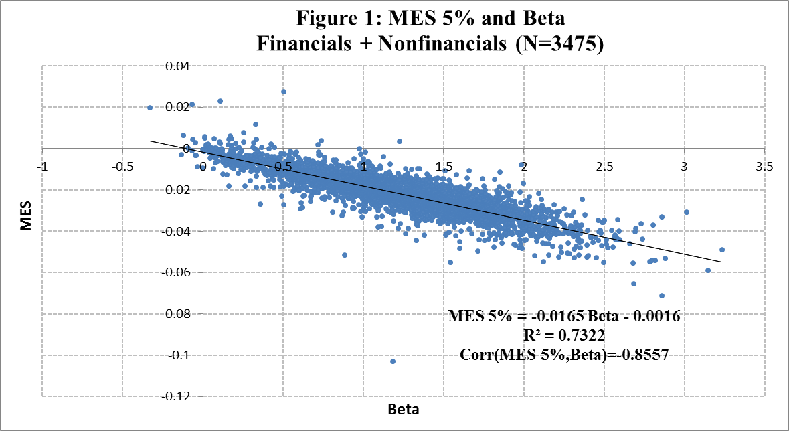

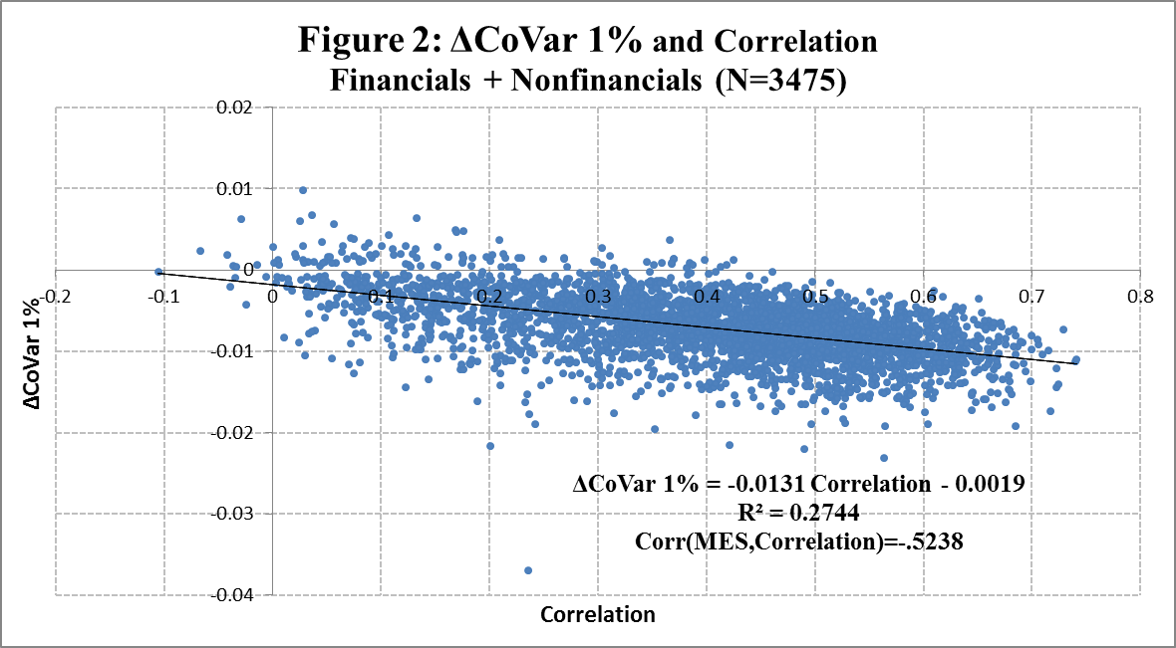

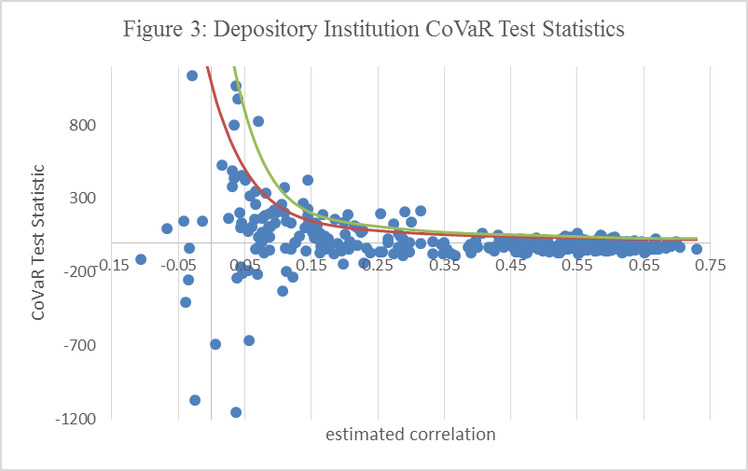

10% CV

5% CV

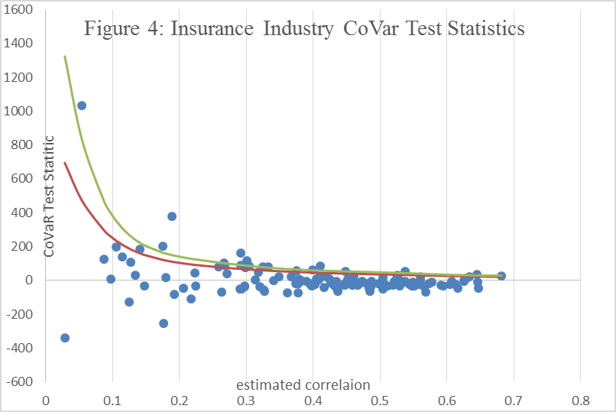

10% CV

5% CV

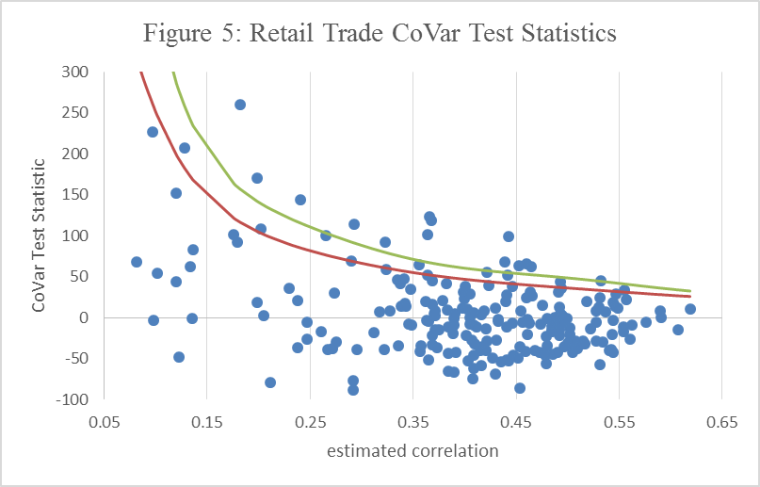

5% CV

10% CV

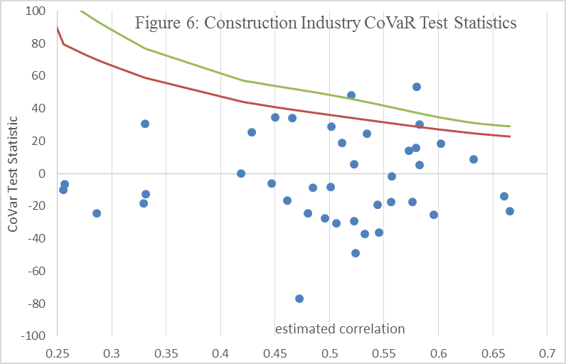

10% CV

5% CV

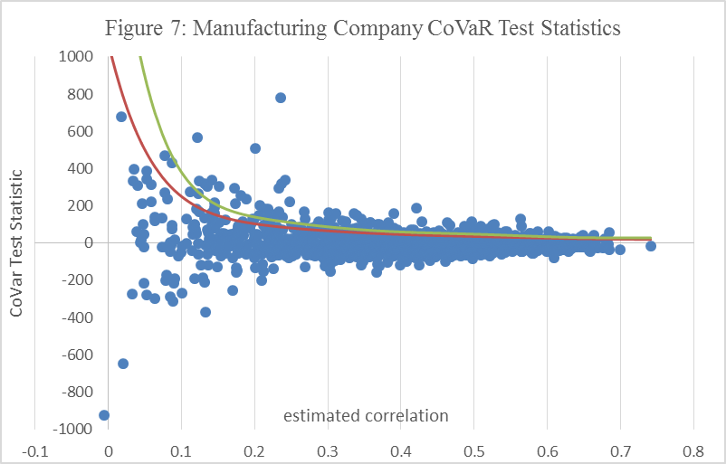

10% CV

5% CV

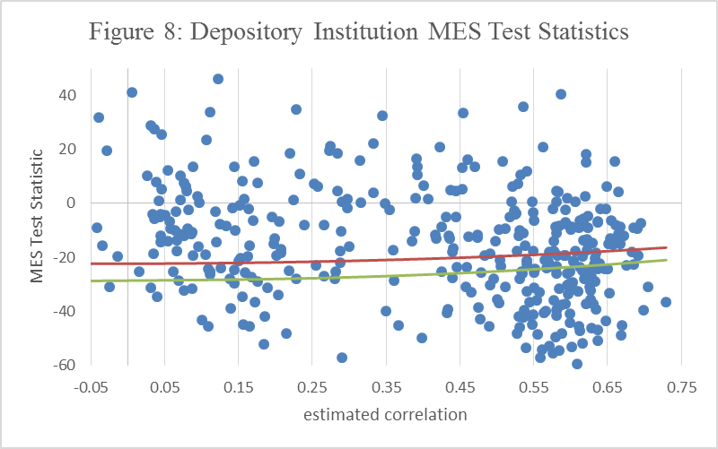

10% CV

5% CV

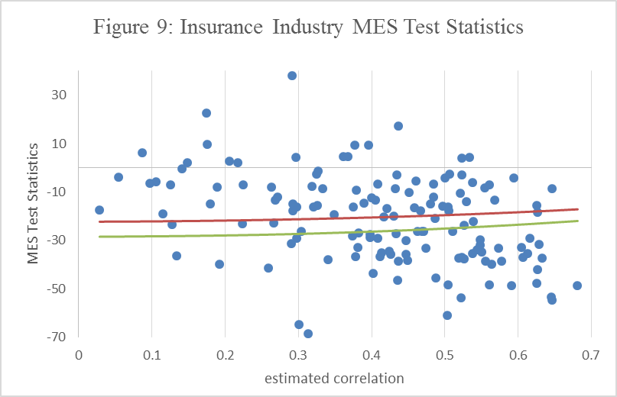

10% CV

5% CV

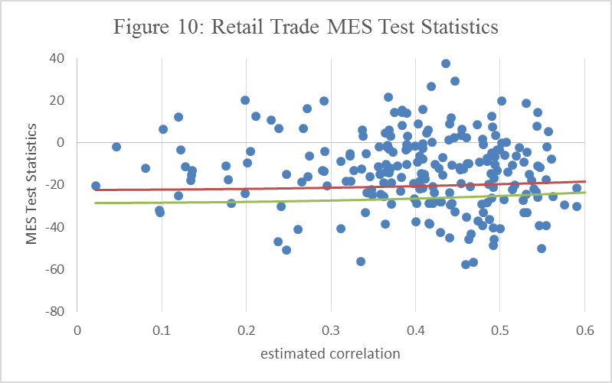

10% CV

5% CV

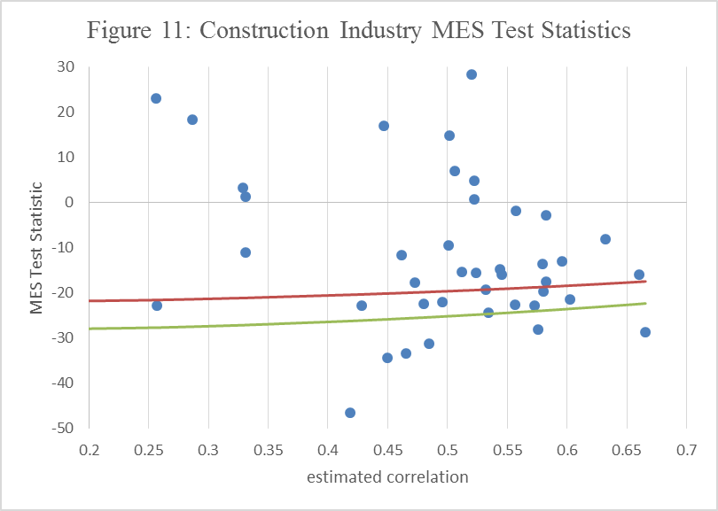

10% CV

5% CV

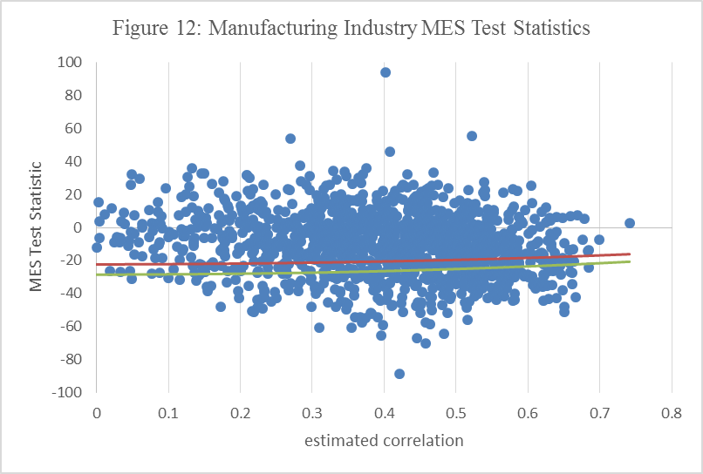

5% CV

10% CV

1. The authors are, respectively, Senior Financial Economist, Federal Deposit Insurance Corporation and Resident Scholar, The American Enterprise Institute. The views in this paper are those of the authors alone. They do not represent the official views of the American Enterprise Institute or the Federal Deposit Insurance Corporation. Emails: [paul.kupiec@aei.org](mailto:paul.kupiec@aei.org) (corresponding author), [leguntay@fdic.gov](mailto:leguntay@fdic.gov).
2. These papers include [1], [2], [3], and [6]. See [5] for a recent survey of this literature and [7] or [4] for a critical assessment.
3. In this literature, a 99 percent VaR measure is taken to be identical to the 1 percent quantile of the underlying return distribution.
4. CoVaR is very similar to the value at risk stress testing methodology developed in [8].
5. See, for example [7] or [4].
6. MES is estimated on days when the market portfolio realization is in the lower 5 percent tail. This within-sample condition is likely less severe than the returns associated with a financial crisis. Scaled MES is an approximation for the expected losses on financial crisis days. It is based on an extreme value approximation that links expected losses under more extreme events to sample MES estimates based on less restrictive conditions.
7. We use the quantile regression package QUANTREG in R.
8. We required data in both CRSP and Compustat because we had anticipated the need to relate systemic risk measures to firm characteristics typically measured using accounting data. For this draft, we have not used the accounting information.