module three, part two: panel data analysis
in Economic Education research using limdep (Nlogit)

Part Two of Module Three provides a cookbook-type demonstration of the steps required to use LIMDEP (NLOGIT) in panel data analysis. Users of this model need to have completed Module One, Parts One and Two, and Module Three, Part One. That is, from Module One users are assumed to know how to get data into LIMDEP, recode and create variables within LIMDEP, and run and interpret regression results. They are also expected to know how to test linear restrictions on sets of coefficients as done in Module One, Parts One and Two. Module Three, Parts Three and Four demonstrate in STATA and SAS what is done here in LIMDEP.

THE CASE

As described in Module Three, Part One, Becker, Greene and Siegfried (2009) examine the extent to which undergraduate degrees (BA and BS) in economics or Ph.D. degrees (PhD) in economics drive faculty size at those U.S. institutions that offer only a bachelor degree and those that offer both bachelor degrees and PhDs. Here we retrace their analysis for the institutions that offer only the bachelor degree. We provide and demonstrate the LIMDEP (NLOGIT) code necessary to duplicate their results.

DATA FILE

The following panel data are provided in the comma separated values (CSV) text file “bachelors.csv”, which will automatically open in EXCEL by simply double clicking on it after it has been downloaded to your hard drive. Your EXCEL spreadsheet should look like this:

“College” identifies the bachelor degree-granting institution by a number 1 through 18.

“Year” runs from 1996 through 2006.

“Degrees” is the number of BS or BA degrees awarded in each year by each college.

“DegreBar” is the average number of degrees awarded by each college for the 16-year period.

“Public” equals 1 if the institution is a public college and 2 if it is a private college.

“Faculty” is the number of tenured or tenure-track economics department faculty members.

“Bschol” equals 1 if the college has a business program and 0 if not.

“T” is the time trend running from −7 to 8, corresponding to years from 1996 through 2006.

“MA_Deg” is a three-year moving average of degrees (unknown for the first two years).

College | Year | Degrees | DegreBar | Public | Faculty | Bschol | T | MA_Deg
1 | 1991 | 50 | 47.375 | 2 | 11 | 1 | -7 | 0
1 | 1992 | 32 | 47.375 | 2 | 8 | 1 | -6 | 0
1 | 1993 | 31 | 47.375 | 2 | 10 | 1 | -5 | 37.667
1 | 1994 | 35 | 47.375 | 2 | 9 | 1 | -4 | 32.667
↓ | ↓ | ↓ | ↓ | ↓ | ↓ | ↓ |  | ↓
1 | 2003 | 57 | 47.375 | 2 | 7 | 1 | 5 | 56
1 | 2004 | 57 | 47.375 | 2 | 10 | 1 | 6 | 55.667
1 | 2005 | 57 | 47.375 | 2 | 10 | 1 | 7 | 57
1 | 2006 | 51 | 47.375 | 2 | 10 | 1 | 8 | 55
2 | 1991 | 16 | 8.125 | 2 | 3 | 1 | -7 | 0
2 | 1992 | 14 | 8.125 | 2 | 3 | 1 | -6 | 0
2 | 1993 | 10 | 8.125 | 2 | 3 | 1 | -5 | 13.333
↓ | ↓ | ↓ | ↓ | ↓ | ↓ | ↓ |  | ↓
2 | 2004 | 10 | 8.125 | 2 | 3 | 1 | 6 | 12.667
2 | 2005 | 7 | 8.125 | 2 | 3 | 1 | 7 | 11.333
2 | 2006 | 6 | 8.125 | 2 | 3 | 1 | 8 | 7.667
3 | 1991 | 40 | 35.5 | 2 | 8 | 1 | -7 | 0
3 | 1992 | 31 | 37.125 | 2 | 8 | 1 | -6 | 0
↓ | ↓ | ↓ | ↓ | ↓ | ↓ | ↓ |  | ↓
17 | 2004 | 64 | 39.3125 | 2 | 5 | 0 | 6 | 54.667
17 | 2005 | 37 | 39.3125 | 2 | 4 | 0 | 7 | 51.333
17 | 2006 | 53 | 39.3125 | 2 | 4 | 0 | 8 | 51.333
18 | 1991 | 14 | 8.4375 | 2 | 4 | 0 | -7 | 0
18 | 1992 | 10 | 8.4375 | 2 | 4 | 0 | -6 | 0
18 | 1993 | 10 | 8.4375 | 2 | 4 | 0 | -5 | 11.333
18 | 1994 | 7 | 8.4375 | 2 | 3.5 | 0 | -4 | 9
↓ | ↓ | ↓ | ↓ | ↓ | ↓ | ↓ |  | ↓
18 | 2005 | 4 | 8.4375 | 2 | 2.5 | 0 | 7 | 7.333
18 | 2006 | 7 | 8.4375 | 2 | 3 | 0 | 8 | 6

If you opened this CSV file in a word processor or text editing program, it would show that each of the 289 lines (including the headers) corresponds to a row in the EXCEL table, but variable values would be separated by commas and not appear neatly one on top of the other as in EXCEL.

As discussed in Module One, Part Two, older versions of LIMDEP (NLOGIT) have a data matrix default restriction of no more than 222 rows (records per variable), 900 columns (number of variables) and 200,000 cells. LIMDEP 9 and NLOGIT 4.0 automatically adjust the data constraints but in older versions the number of cells must be increased to accommodate work with our data set. After opening Limdep, the number of working cells can be increased by clicking the Project button on the top ribbon, going to Settings, and changing the number of cells. Going from the default 200,000 cells to 900,000 cells (1,000 Rows and 900 columns) is more than sufficient for this panel data set.

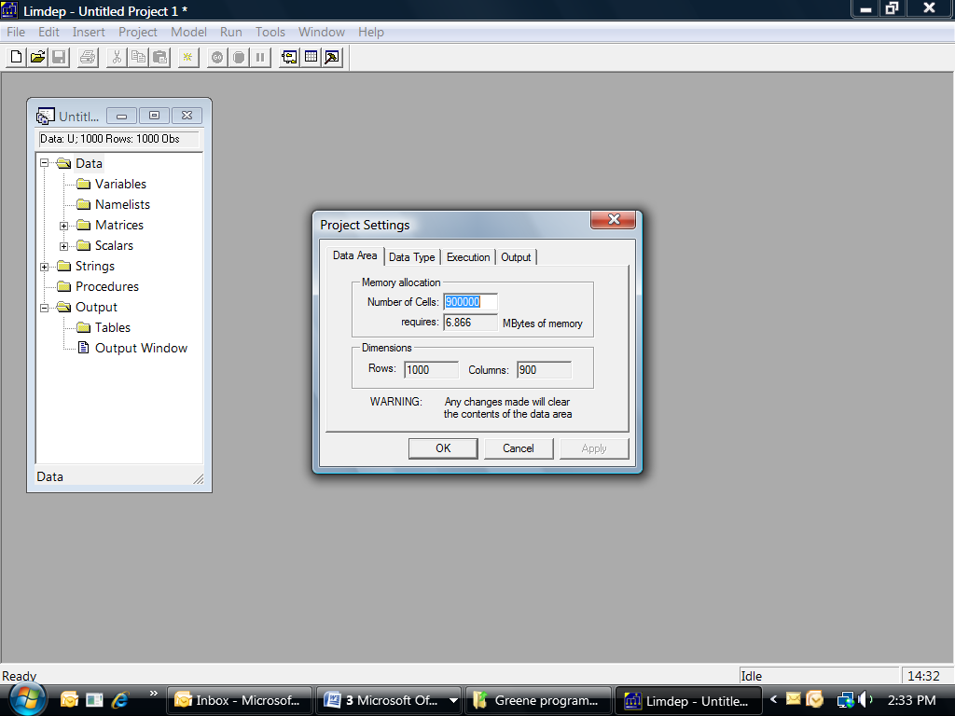

We could write a “READ” command to bring this text data file into LIMDEP but like EXCEL it can be imported into LIMDEP directly by clicking the Project button on the top ribbon, going to Import, and then clicking on Variables, from which the bachelors.cvs file can be located wherever it is stored (in our case in the “Greene programs 2” folder). Hitting the Open button will bring the data set into LIMDEP, which can be checked by clicking the “Activate Data Editor” button, which is second from the right on the tool bar or go to Data Editor in the Window’s menu, as described and demonstrated in Module One, Part Two.

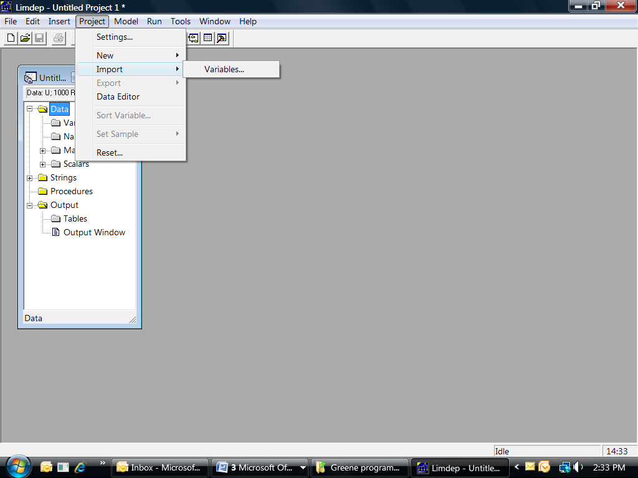

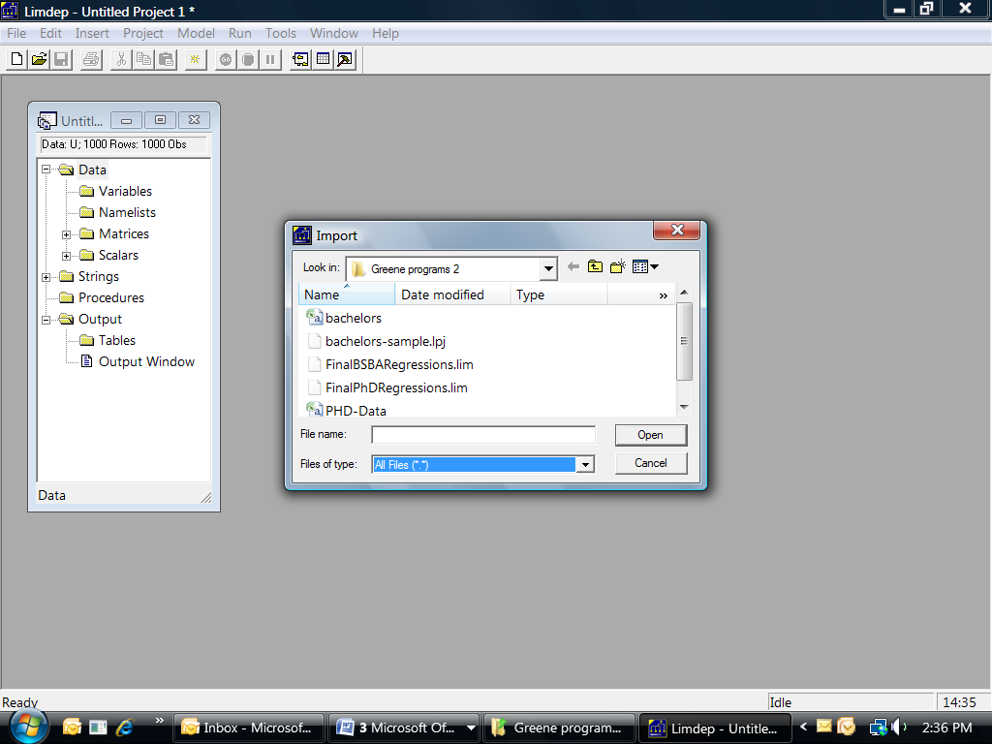

In addition to a visual inspection of the data via the “Activate Data Editor,” we use the “dstat” command to check the descriptive statistics. First, however, we need to remove the two years (1991 and 1992) for which no data are available for the degree moving average measure. This is done with the “Reject” command. In our “File:New Text/Command Document” (which was described in Module One, Part Two), we have

reject ; year < 1993 $
dstat;rhs=*$

which upon highlighting and pressing “Go” yields
--> reject ; year < 1993 $
--> dstat;rhs=*$
Descriptive Statistics
All results based on nonmissing observations.
==============================================================================
Variable Mean Std.Dev. Minimum Maximum Cases Missing
==============================================================================
All observations in current sample
--------+---------------------------------------------------------------------
COLLEGE | 9.50000 5.19845 1.00000 18.0000 252 0
YEAR | 1999.50 4.03915 1993.00 2006.00 252 0
DEGREES | 23.1111 19.2264 .000000 81.0000 252 0
DEGREBAR| 23.6528 18.0143 2.00000 62.4375 252 0
PUBLIC | 1.77778 .416567 1.00000 2.00000 252 0
FACULTY | 6.51786 3.13677 2.00000 14.0000 252 0
BSCHOOL | .388889 .488468 .000000 1.00000 252 0
T | 1.50000 4.03915 -5.00000 8.00000 252 0
MA_DEG | 23.1931 18.5540 1.33333 80.0000 252 0

constant coefficient REGRESSION

The constant coefficient panel data model for the faculty size data-generating process for bachelor degree-granting undergraduate departments is given by

Faculty size_{it} = β₁ + β₂T_{t} + β₃BA&S_{it} + β₄MEANBA&S_{i} + β₅PUBLIC_{i}
+ β₆Bschl + β₇MA_Deg_{it} + ε_{it}

where the error term ε_{it} is independent and identically distributed (iid) across institutions and over time and E(ε_{it}²|x_{it}) = σ² , for I = 18 colleges and T = 14 years (−5 through 8) for 252 complete records. The Limdep OLS regression command that needs to be entered into the command document (again, following the procedure for opening the command document window shown in Module One, Part Two), including the standard error adjustment for clustering is

reject ; year < 1993 $
regress
;lhs=faculty;rhs=one,t,degrees,degrebar,public,bschool,MA_deg
;cluster=14$

Upon highlighting and hitting the “Go” button the Output file shows the following results

--> reject ; year < 1993 $
--> regress;lhs=faculty;rhs=one,t,degrees,degrebar,public,bschool,MA_deg
;cluster=14$

+----------------------------------------------------+
| Ordinary least squares regression |
| LHS=FACULTY Mean = 6.517857 |
| Standard deviation = 3.136769 |
| Number of observs. = 252 |
| Model size Parameters = 7 |
| Degrees of freedom = 245 |
| Residuals Sum of squares = 868.4410 |
| Standard error of e = 1.882726 |
| Fit R-squared = .6483574 |
| Adjusted R-squared = .6397458 |
| Model test F[ 6, 245] (prob) = 75.29 (.0000) |
| Diagnostic Log likelihood = -513.4686 |
| Restricted(b=0) = -645.1562 |
| Chi-sq [ 6] (prob) = 263.38 (.0000) |
| Info criter. LogAmemiya Prd. Crt. = 1.292840 |
| Akaike Info. Criter. = 1.292826 |
| Bayes Info. Criter. = 1.390866 |
| Autocorrel Durbin-Watson Stat. = .3295926 |
| Rho = cor[e,e(-1)] = .8352037 |
| Model was estimated Jul 16, 2009 at 04:21:28PM |
+----------------------------------------------------+
+---------------------------------------------------------------------+
| Covariance matrix for the model is adjusted for data clustering. |
| Sample of 252 observations contained 18 clusters defined by |
| 14 observations (fixed number) in each cluster. |
| Sample of 252 observations contained 1 strata defined by |
| 252 observations (fixed number) in each stratum. |
+---------------------------------------------------------------------+
+--------+--------------+----------------+--------+--------+----------+
|Variable| Coefficient | Standard Error |t-ratio |P[|T|>t]| Mean of X|
+--------+--------------+----------------+--------+--------+----------+
|Constant| 10.1397*** .91063 11.135 .0000 |
|T | -.02809 .02227 -1.261 .2083 1.50000|
|DEGREES | -.01636 .01866 -.877 .3814 23.1111|
|DEGREBAR| .10832*** .03378 3.206 .0015 23.6528|
|PUBLIC | -3.86239*** .56950 -6.782 .0000 1.77778|
|BSCHOOL | .58112 .94253 .617 .5381 .38889|
|MA_DEG | .03780** .01810 2.089 .0377 23.1931|
+--------+------------------------------------------------------------+
| Note: ***, **, * = Significance at 1%, 5%, 10% level. |
+---------------------------------------------------------------------+

Contemporaneous degrees have little to do with current faculty size but both overall number of degrees awarded (the school means) and the moving average of degrees (MA_DEG) have significant effects. It takes an increase of 26 or 27 bachelor degrees in the moving average to expect just one more faculty position. Whether it is a public or a private college is highly significant. Moving from a public to a private college lowers predicted faculty size by nearly four members for otherwise comparable institutions. There is an insignificant erosion of tenured and tenure-track faculty size over time. Finally, while economics departments in colleges with a business school tend to have a larger permanent faculty, ceteris paribus, the effect is small and insignificant.

fixed-effects REGRESSION

To estimate the fixed-effects model we can either insert seventeen (0,1) covariates to capture the unique effect of each of the 18 colleges (where each of the 17 dummy coefficients are measured relative to the constant term) or the insert of 18 dummy variables with no overall constant term in the OLS regression. The results for the other coefficients and for R² will be identical either way, while the the constant terms, since they measure the difference of each college from the 18th in the first case, or the difference of all 18 from zero in the second, will differ. This difference is inconsequential for the regression of interest. Which way the model is estimated is purely a matter of convenience and preference.

An important implication of the fixed effects specification is that no time invariant variables can be included in the equation because they would be perfectly correlated with the respective college dummies. Thus, the overall school mean number of degrees, the public or private dummy variables, and business school dummy variables must all be excluded from the fixed effects model.

A LIMDEP (NLOGIT) program to be run from the Test/Command Document, including the commands to create the dummy variables then run the regression is shown below. (An alternative, more compact way to create the dummies and run the regression is shown in the Appendix.)

reject ; year < 1993 $

create
;Col1=college=1
;Col2=college=2
;Col3=college=3
;Col4=college=4
;Col5=college=5
;Col6=college=6$
create
;Col7=college=7
;Col8=college=8
;Col9=college=9
;Col10=college=10
;Col11=college=11
;Col12=college=12$
create
;Col13=college=13
;Col14=college=14
;Col15=college=15
;Col16=college=16
;Col17=college=17
;Col18=college=18$

regress;lhs=faculty;rhs=one,t,degrees,MA_deg,
Col1,Col2,Col3,Col4,Col5,Col6,Col7,Col8,Col9,
Col10,Col11,Col12,Col13,Col14,Col15,Col16,Col17; cluster=14$

The resulting regression information appearing in the output window is
+---------------------------------------------------------------------+
| Covariance matrix for the model is adjusted for data clustering. |
| Sample of 252 observations contained 18 clusters defined by |
| 14 observations (fixed number) in each cluster. |
+---------------------------------------------------------------------+

----------------------------------------------------------------------
Ordinary least squares regression ............
LHS=FACULTY Mean = 6.51786
Standard deviation = 3.13677
Number of observs. = 252
Model size Parameters = 21
Degrees of freedom = 231
Residuals Sum of squares = 146.63709
Standard error of e = .79674
Fit R-squared = .94062
Adjusted R-squared = .93548
Model test F[ 20, 231] (prob) = 183.0(.0000)
Diagnostic Log likelihood = -289.34751
Restricted(b=0) = -645.15625
Chi-sq [ 20] (prob) = 711.6(.0000)
Info criter. LogAmemiya Prd. Crt. = -.37441
Akaike Info. Criter. = -.37480
Bayes Info. Criter. = -.08068
Model was estimated on Sep 23, 2009 at 06:44:38 PM
--------+-------------------------------------------------------------
Variable| Coefficient Standard Error t-ratio P[|T|>t] Mean of X
--------+-------------------------------------------------------------
Constant| 2.69636*** .15109 17.846 .0000
T| -.02853 .02245 -1.271 .2051 1.50000
DEGREES| -.01608 .01521 -1.058 .2913 23.1111
MA_DEG| .03985*** .01485 2.683 .0078 23.1931
COL1| 5.77747*** .76816 7.521 .0000 .05556
COL2| .15299*** .01343 11.392 .0000 .05556
COL3| 4.29759*** .55420 7.755 .0000 .05556
COL4| 6.28973*** .65533 9.598 .0000 .05556
COL5| 4.91094*** .56987 8.618 .0000 .05556
COL6| 5.02016*** .02561 196.041 .0000 .05556
COL7| 1.21384*** .01321 91.876 .0000 .05556
COL8| .77797*** .06785 11.466 .0000 .05556
COL9| 3.16474*** .06270 50.478 .0000 .05556
COL10| 2.86345*** .15540 18.427 .0000 .05556
COL11| 5.15181*** .02403 214.385 .0000 .05556
COL12| -.06802*** .02153 -3.160 .0018 .05556
COL13| 3.98895*** 1.01415 3.933 .0001 .05556
COL14| -.63196*** .11986 -5.272 .0000 .05556
COL15| 8.25859*** .47255 17.477 .0000 .05556
COL16| 8.00970*** .55461 14.442 .0000 .05556
COL17| .43544 .59258 .735 .4632 .05556
--------+-------------------------------------------------------------
Note: ***, **, * = Significance at 1%, 5%, 10% level.
----------------------------------------------------------------------

Once again, contemporaneous degrees is not a driving force in faculty size. An F test is not needed to assess if at least one of the 17 colleges differ from college 18. With the exception of college 17, each of the other colleges are significantly different. The moving average of degrees is again significant.

The preceding approach, of computing all the dummy variables and building them into the regression, is likely to become unduly cumbersome if the number of colleges (units) is very large. Most contemporary software, including LIMDEP will do this computation automatically without explicitly computing the dummy variables and including them in the equation. As an alternative to specifying all the dummies in the regression command, the same results can be obtained with the simpler "FixedEffects" command:

regress;lhs=faculty;rhs=one,t,degrees,MA_deg
;Panel;Str=College
;FixedEffects;Robust$

----------------------------------------------------------------------
Least Squares with Group Dummy Variables..........
Ordinary least squares regression ............
LHS=FACULTY Mean = 6.51786
Standard deviation = 3.13677
Number of observs. = 252
Model size Parameters = 21
Degrees of freedom = 231
Residuals Sum of squares = 146.63709
Standard error of e = .79674
Fit R-squared = .94062
Adjusted R-squared = .93548
Model test F[ 20, 231] (prob) = 183.0(.0000)
Diagnostic Log likelihood = -289.34751
Restricted(b=0) = -645.15625
Chi-sq [ 20] (prob) = 711.6(.0000)
Info criter. LogAmemiya Prd. Crt. = -.37441
Akaike Info. Criter. = -.37480
Bayes Info. Criter. = -.08068
Model was estimated on Sep 23, 2009 at 06:44:38 PM
Estd. Autocorrelation of e(i,t) = .293724
Robust cluster corrected covariance matrix used
Panel:Groups Empty 0, Valid data 18
Smallest 14, Largest 14
Average group size in panel 14.00
--------+-------------------------------------------------------------
Variable| Coefficient Standard Error t-ratio P[|T|>t] Mean of X
--------+-------------------------------------------------------------
T| -.02853 .02245 -1.271 .2050 1.50000
DEGREES| -.01608 .01521 -1.058 .2912 23.1111
MA_DEG| .03985*** .01485 2.683 .0078 23.1931
--------+-------------------------------------------------------------
Note: ***, **, * = Significance at 1%, 5%, 10% level.
----------------------------------------------------------------------

random-effects REGRESSION

Finally, consider the random-effects model in which we employ Mundlak’s (1978) approach to estimating panel data. The Mundlak model posits that the fixed effects in the equation, β_{1i} , can be projected upon the group means of the time-varying variables, so that

β_{1i} = β₁ + δ′

where is the set of group (school) means of the time-varying variables and w_{i} is a (now) random effect that is uncorrelated with the variables and disturbances in the model. Logically, adding the means to the equations picks up the correlation between the school effects and the other variables. We could not incorporate the mean number of degrees awarded in the fixed-effects model (because it was time invariant) but this variable plays a critical role in the Mundlak approach to panel data modeling and estimation.

The random effects model for BA and BS degree-granting undergraduate departments is

Faculty size_{it} = β₁ + β₂T_{t} + β₃BA&S_{it} + β₄MEANBA&S_{i} + β₅MOVAVBA&BS
+ β₆PUBLIC_{i} + β₇Bschl + ε_{it} + u_{i}

where error term ε is iid over time, E(ε_{it}²|x_{it}) = σ² for I = 18 and T_{i} = 14 and E[u_{i}²] = θ² for I = 18. The LIMDEP program to be run from the Text/Command Document (with 1991 and 1992 data suppressed) is

regress
;lhs=faculty
;rhs=one,t,degrees,degrebar,public,bschool,MA_deg
;pds=14
;panel
;random
;robust$

The resulting regression information appearing in the output window is
--> regress
;lhs=faculty;rhs=one,t,degrees,degrebar,public,bschool,MA_deg
;pds=14;panel;random;robust$

----------------------------------------------------------------------
OLS Without Group Dummy Variables.................
Ordinary least squares regression ............
LHS=FACULTY Mean = 6.51786
Standard deviation = 3.13677
Number of observs. = 252
Model size Parameters = 7
Degrees of freedom = 245
Residuals Sum of squares = 868.44104
Standard error of e = 1.88273
Fit R-squared = .64836
Adjusted R-squared = .63975
Model test F[ 6, 245] (prob) = 75.3(.0000)
Diagnostic Log likelihood = -513.46861
Restricted(b=0) = -645.15625
Chi-sq [ 6] (prob) = 263.4(.0000)
Info criter. LogAmemiya Prd. Crt. = 1.29284
Akaike Info. Criter. = 1.29283
Bayes Info. Criter. = 1.39087
Model was estimated on Sep 23, 2009 at 07:17:22 PM
Panel Data Analysis of FACULTY [ONE way]
Unconditional ANOVA (No regressors)
Source Variation Deg. Free. Mean Square
Between 2312.22321 17. 136.01313
Residual 157.44643 234. .67285
Total 2469.66964 251. 9.83932
--------+-------------------------------------------------------------
Variable| Coefficient Standard Error t-ratio P[|T|>t] Mean of X
--------+-------------------------------------------------------------
T| -.02809 .03030 -.927 .3549 1.50000
DEGREES| -.01636 .02334 -.701 .4839 23.1111
DEGREBAR| .10832*** .02047 5.293 .0000 23.6528
PUBLIC| -3.86239*** .29652 -13.026 .0000 1.77778
BSCHOOL| .58112** .25115 2.314 .0215 .38889
MA_DEG| .03780 .02907 1.300 .1947 23.1931
Constant| 10.1397*** .52427 19.341 .0000
--------+-------------------------------------------------------------
Note: ***, **, * = Significance at 1%, 5%, 10% level.
----------------------------------------------------------------------

+----------------------------------------------------+
| Panel:Groups Empty 0, Valid data 18 |
| Smallest 14, Largest 14 |
| Average group size 14.00 |
| There are 3 vars. with no within group variation. |
| DEGREBAR PUBLIC BSCHOOL |
+----------------------------------------------------+

----------------------------------------------------------------------
Random Effects Model: v(i,t) = e(i,t) + u(i)
Estimates: Var[e] = .643145
Var[u] = 2.901512
Corr[v(i,t),v(i,s)] = .818559
Lagrange Multiplier Test vs. Model (3) =1096.30
( 1 degrees of freedom, prob. value = .000000)
(High values of LM favor FEM/REM over CR model)
Baltagi-Li form of LM Statistic = 1096.30
Sum of Squares 868.488173
R-squared .648338
Robust cluster corrected covariance matrix used
--------+-------------------------------------------------------------
Variable| Coefficient Standard Error b/St.Er. P[|Z|>z] Mean of X
--------+-------------------------------------------------------------
T| -.02853 .02146 -1.329 .1838 1.50000
DEGREES| -.01609 .01793 -.897 .3696 23.1111
DEGREBAR| .10610*** .03228 3.287 .0010 23.6528
PUBLIC| -3.86365*** .54685 -7.065 .0000 1.77778
BSCHOOL| .58176 .90497 .643 .5203 .38889
MA_DEG| .03981** .01728 2.305 .0212 23.1931
Constant| 10.1419*** .87456 11.597 .0000
--------+-------------------------------------------------------------
Note: ***, **, * = Significance at 1%, 5%, 10% level.
----------------------------------------------------------------------

The marginal effect of an additional economics major is again insignificant but slightly negative within the sample. Both the short-term moving average number and long-term average number of bachelor degrees are significant. A long-term increase of about 10 students earning degrees in economics is required to predict that one more tenured or tenure-track faculty member is in a department. Ceteris paribus, economics departments at private institutions are smaller than comparable departments at public schools by a large and significant number of four members. Whether there is a business school present is insignificant. There is no meaningful trend in faculty size.

Concluding Remarks

The goal of this hands-on component of this third of four modules is to enable economic education researchers to make use of panel data for the estimation of constant coefficient, fixed-effects and random-effects panel data models in LIMDEP (NLOGIT). It was not intended to explain all of the statistical and econometric nuances associated with panel data analysis. For this an intermediate level econometrics textbook (such as Jeffrey Wooldridge, Introductory Econometrics) or advanced econometrics textbook (such as William Greene, Econometric Analysis) should be consulted.

Appendix:

Alternatives for creating college dummy variables and running regressions in LIMDEP (NLOGIT)

There are two alternative ways to create the college dummy variables for use in the regression.

First is the “create ; expand(college)$” command, where COLLEGE is expanded as _COLLEG_, with the following resulting output:

COLLEGE was expanded as _COLLEG_.
Largest value = 18. 18 New variables were created.
Category
1 New variable = COLLEG01 Frequency= 14
2 New variable = COLLEG02 Frequency= 14
3 New variable = COLLEG03 Frequency= 14
4 New variable = COLLEG04 Frequency= 14
5 New variable = COLLEG05 Frequency= 14
6 New variable = COLLEG06 Frequency= 14
7 New variable = COLLEG07 Frequency= 14
8 New variable = COLLEG08 Frequency= 14
9 New variable = COLLEG09 Frequency= 14
10 New variable = COLLEG10 Frequency= 14
11 New variable = COLLEG11 Frequency= 14
12 New variable = COLLEG12 Frequency= 14
13 New variable = COLLEG13 Frequency= 14
14 New variable = COLLEG14 Frequency= 14
15 New variable = COLLEG15 Frequency= 14
16 New variable = COLLEG16 Frequency= 14
17 New variable = COLLEG17 Frequency= 14
18 New variable = COLLEG18 Frequency= 14
Note, this is a complete set of dummy variables. If
you use this set in a regression, drop the constant.

The second method for creating dummies and running the regression is an even more condensed, and as yet an undocumented feature in the LIMDEP (NLOGIT) manual:

regress;lhs=faculty;rhs=one,t,degrees,MA_deg,expand(college)
;cluster=college$

which produces the same results as the fixed effects regression command we used at the beginning of this duscussion.

References

Becker, William, William Greene and John Siegfried (2009). “Does Teaching Load Affect Faculty Size? ” Working Paper (July).
Greene, William (2008). Econometric Analysis. 6th Edition, New Jersey: Prentice Hall.

Mundlak, Yair (1978). "On the Pooling of Time Series and Cross Section Data," Econometrica. Vol. 46. No. 1 (January): 69-85.

Wooldridge, Jeffrey (2009). Introductory Econometrics. 4th Edition, Mason OH: South-Western.

